

**CAPSTONE PROJECT REPORT**

**Report 3 – Software Requirement Specification**

– Hanoi, Jan 2025 –

**Table of Contents**

I. Record of Changes 3

II. Software Requirement Specification 4

1. Overall Requirements 4

1.1 Context Diagram 4

1.2 Main Workflows 5

1.3 User Requirements 6

1.4 System Functionalities 11

1.5 Entity Relationship Diagram 14

2. Use Case Specifications 16

2.1 User 16

2.2 Medicine 21

2.3 Medical Supply 27

2.4 Medical Record 30

2.5 Prescription 36

3. Functional Requirements 41

3.1 User Authentication 41

3.3 Medical Management 49

3.4 MedicineManagement 62

3.5 PrescriptionManagement 70

3.6 MedicalSupplyManagement 86

4. Non-Functional Requirements 100

5. Requirement Appendix 101

5.1 Business Rules 101

5.2 System Messages 102

# 

# I. Record of Changes

| **Date** | **A* M, D** | **In charge** | **Change Description** |
| --- | --- | --- | --- |
| 20/3/2025 | A | vuongdv | Overall Requirement, Context Diagram |
| 20/3/2025 | A | thaidq | Main Workflows |
| 25/3/2025 | A | tungbd | User Requirement |
| 25/3/2025 | A | thaidq | Usecase Specifications |
| 9/5/2025 | M | tungbd | Modify the report according to the council's comments. |
| 9/5/2025 | M | thinhnt | Modify the report according to the council's comments. |
| 24/5/2025 | M | quypdt | Modify the report according to the council's comments. |
|  |  |  |  |
|  |  |  |  |
|  |  |  |  |
|  |  |  |  |
|  |  |  |  |
|  |  |  |  |

*A - Added M - Modified D - Deleted

*Table 1: Record of Changes*

# II. Software Requirement Specification

## 1. Overall Requirements

### 1.1 Context Diagram

This project aims to develop Commune Health Station Management Software (CHSMS), designed to support commune health stations in managing and operating activities such as medical supplies management, pharmaceutical management, and medical statistics reporting. In addition, it also supports medical examination by storing patient medical records, contributing to making the work of archiving medical examination history easier, especially for patients with regular check-ups.

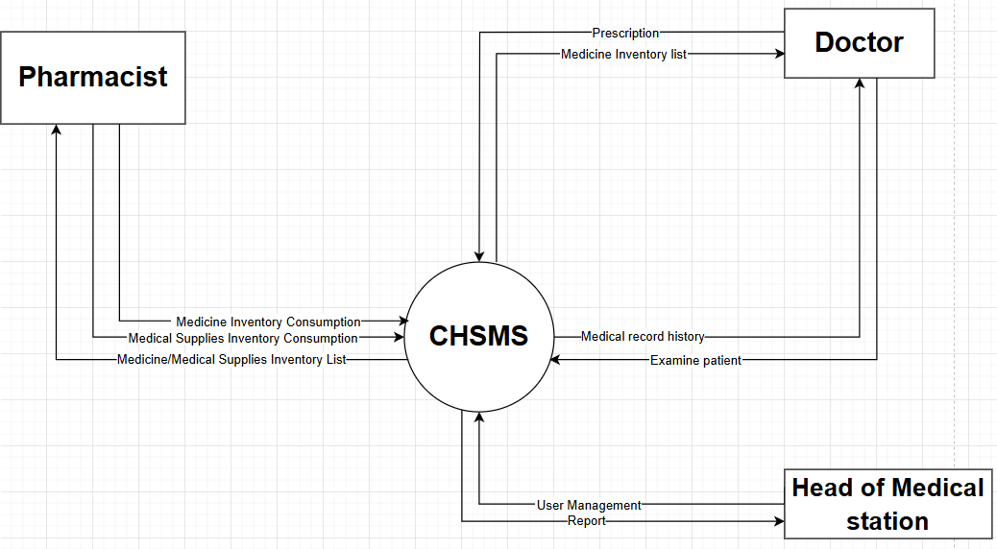

*Figure 1– Context diagram*

### 1.2 Main Workflows

#### 1.2.1 Procedures for medical examination, prescription, use of materials, and dispensing of medicine and supplies

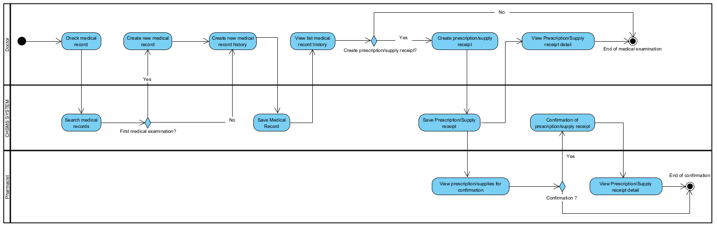

*Figure 2– Procedures for medical examination, prescription, use of materials, and dispensing of medicine and supplies*

#### 1.2.2 Medicine batch import process

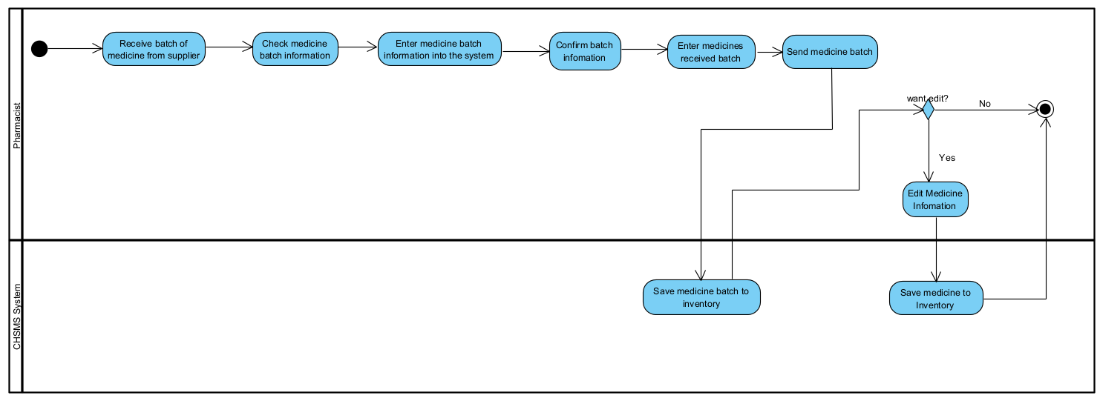

*Figure 3– Medicine batch import process*

#### 1.2.3 Medical Supply batch import process

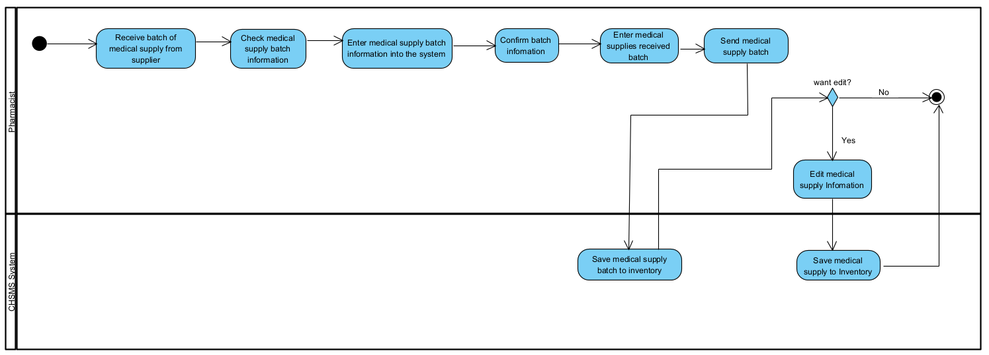

*Figure 4– Medical Supply batch import process*

### 1.3 User Requirements

#### 1.3.1 Actors

| **#** | **Actor** | **Description** |
| --- | --- | --- |
| 1 | Head of health station | Oversees the overall operation of the health station, approves medical records, and manages staff activities within the system. |
| 2 | Doctor | Diagnoses patients, prescribes medicines or medical supplies, and inputs prescription data into the system. |
| 3 | Pharmacist | Dispenses prescribed medicines, verifies prescriptions, updates medicine inventory, and generates related pharmacy reports. Dispenses medical supplies |

*Table 2: Actors descriptions*

#### 1.3.2 Use Cases (UC)

| **ID** | **Use Case** | **Feature** | **Use Case Description** |
| --- | --- | --- | --- |
| 01 | Reset Password | Authentication | Allow users to reset their password when they forget it. |
| 02 | Change password | Authentication | Allow users to change their current password while logged in. |
| 03 | Login | Authentication | Allow users to log in to the system using their credentials. |
| 04 | View user profile | User Profile | Allow users to view their personal information and account details. |
| 05 | Edit user profile | User Profile | Allow users to edit and update their personal information. |
| 06 | Logout | Authentication | Allow users to securely log out of the system. |
| 07 | Dispense MedicalSupply | Medical Supply Management | Allow staff to dispense medical supplies to patients or departments. |
| 08 | Dispense Medicine | Medicine Management | Allow staff to dispense prescribed medicines to patients. |
| 09 | View Prescription list by today | Prescription Management | View all prescriptions created on the current day. |
| 10 | View UseMedicalSupply list by today | Medical Supply Management | View all medical supplies used on the current day. |
| 11 | View today's patient number | Dashboard | Show the total number of patients served today. |
| 12 | View today's prescriptions number | Dashboard | Show the total number of prescriptions created today. |
| 13 | View today's material usage number | Dashboard | Show the number of materials used today. |
| 14 | Manage medicine inventory | Medicine Management | Allow staff to manage and update the medicine inventory. |
| 15 | View added medicine history | Medicine Management | View the history of medicines added to the inventory. |
| 16 | View list medicine in inventory | Medicine Management | View a list of all medicines currently in inventory. |
| 17 | Add medicine to inventory | Medicine Management | Add new or restock medicines to the inventory. |
| 18 | Search medicine | Medicine Management | Search for specific medicines in the inventory. |
| 19 | Update medicine inventory | Medicine Management | Update the details or quantity of medicines in inventory. |
| 20 | Manage user | User Management | Manage user accounts, roles, and permissions. |
| 21 | Change user status | User Management | Activate or deactivate user accounts. |
| 22 | Add user | User Management | Add new user accounts to the system. |
| 23 | View medical record list | Medical Record Management | View a list of all medical records in the system. |
| 24 | Create medical record list | Medical Record Management | Create and maintain new medical records for patients. |
| 25 | View medical record history today | Medical Record Management | View the medical records created or updated today. |
| 26 | Create prescription | Prescription Management | Create a new prescription for a patient. |
| 27 | View personal medical record history list | Medical Record Management | View a personal history list of a patient's medical records. |
| 28 | View medical record history detail | Medical Record Management | View detailed information from a patient's medical record history. |
| 29 | View prescriptions | Prescription Management | View a list of all prescriptions in the system. |
| 30 | View use medical supply list | Medical Supply Management | View a list of all medical supplies used in the system. |
| 31 | Edit use medical supply | Medical Supply Management | Edit or update records of used medical supplies. |
| 32 | Edit prescription | Prescription Management | Edit or update existing prescriptions. |
| 33 | Create external prescription | Prescription Management | Create a prescription for external use, e.g., for patients receiving medication outside the system. |
| 34 | View external prescription list | Prescription Management | View a list of all external prescriptions. |
| 35 | Create Use Medical Supply | Medical Supply Management | Record the use of a medical supply item. |
| 36 | View prescription detail | Prescription Management | View detailed information for a specific prescription. |
| 37 | Edit external prescription | Prescription Management | Edit or update external prescriptions. |
| 38 | View external prescription detail | Prescription Management | View detailed information for a specific external prescription. |
| 39 | View use medical supply detail | Medical Supply Management | View detailed information for a specific use of medical supply |

*Table 3: Use Case descriptions*

#### 1.3.2 Use Case Diagrams

##### 1.3.2.1 UCs for Doctor

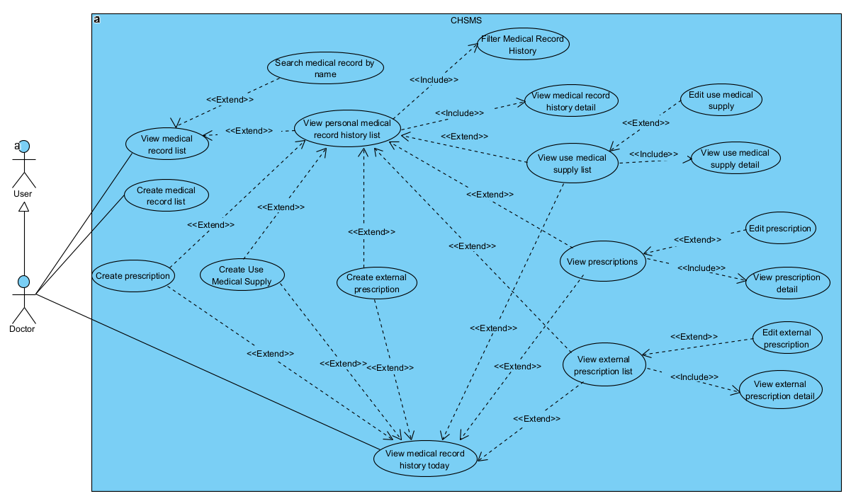

*Figure 5– UCs for Doctor*

##### 1.3.2.2 UCs for Pharmacist

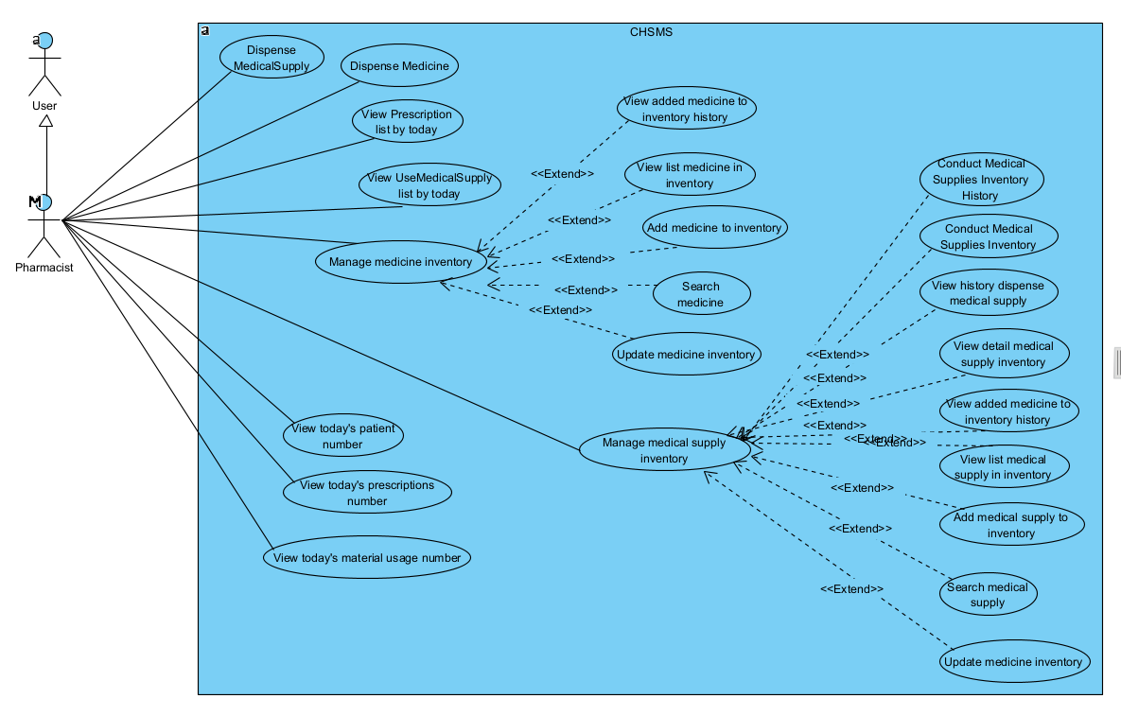

*Figure 6– UCs for Pharmacist*

##### 1.3.2.3 UCs for Head of health station

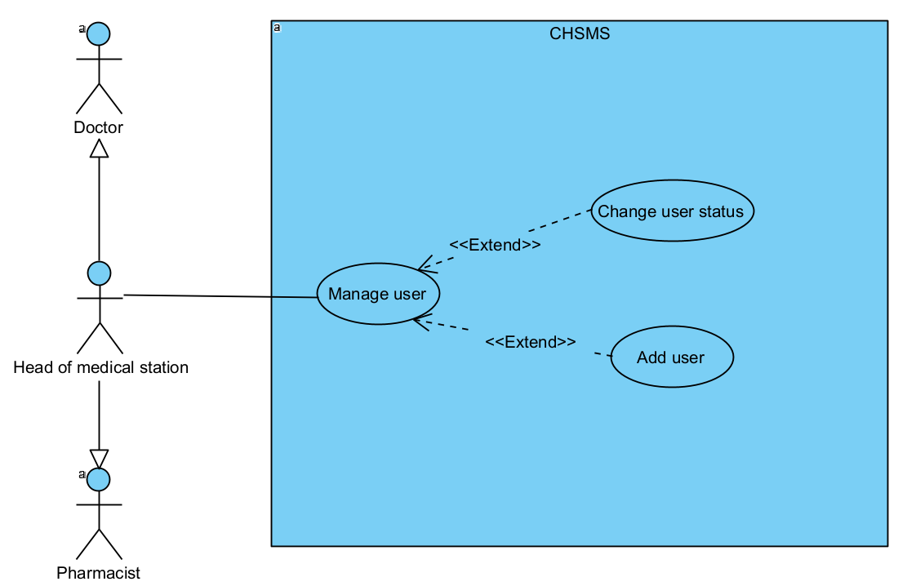

*Figure 7– UCs for Head of health station*

##### 1.3.2.4 UCs for User

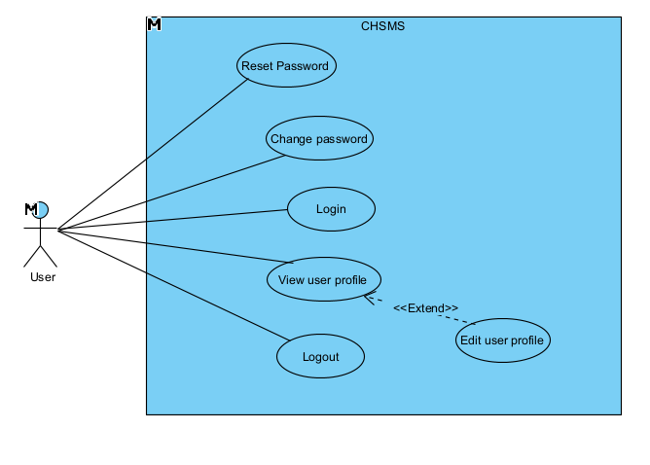

*Figure 8– UCs for User*

### 1.4 System Functionalities

#### 1.4.1 Screens Flow

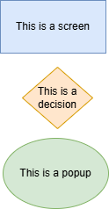

*Figure 9– Screen flow symbol explanation*

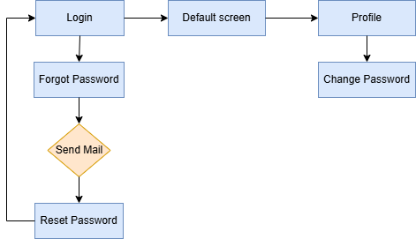

*Figure 10– Screen flow for common user*

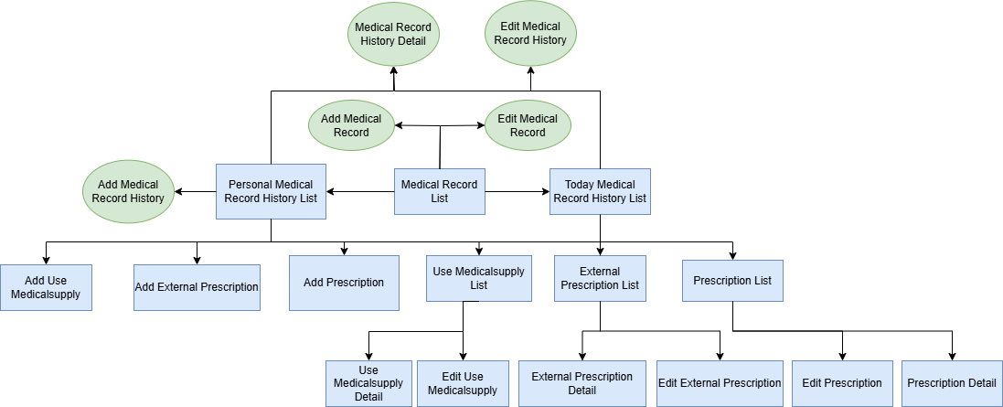

*Figure 11– Screen flow for Doctor*

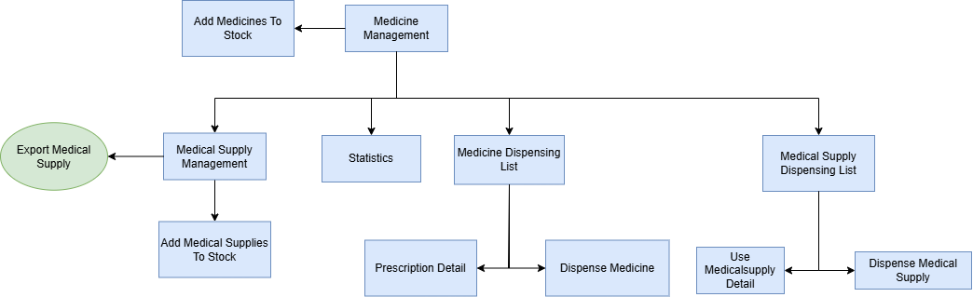

*Figure 12– Screen flow for Pharmacist*

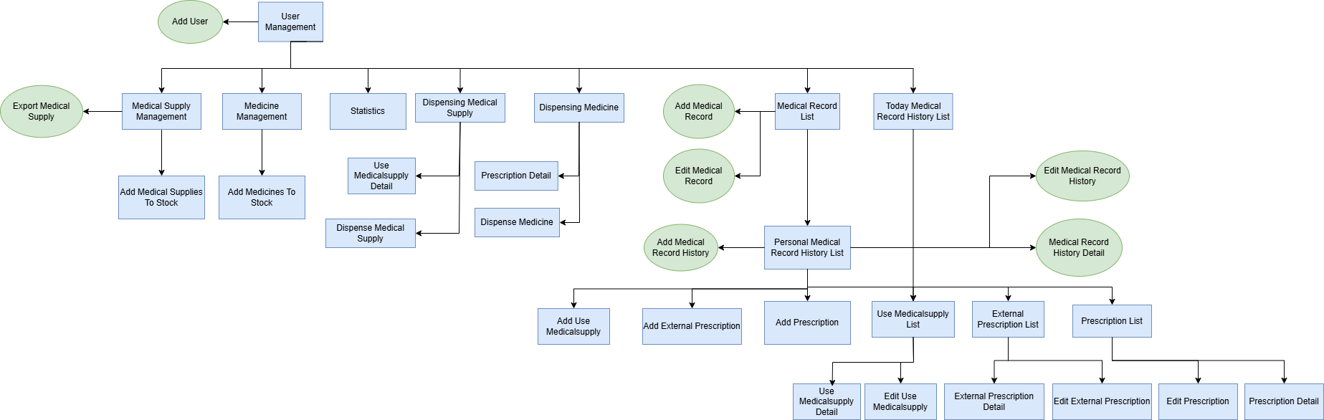

*Figure 13– Screen flow for Head of Medical Station*

#### 1.4.2 Screen Authorization

| **Screen** | **User** | **Head of health station** | **Doctor** | **Pharmacist** |
| --- | --- | --- | --- | --- |
| Profile | X | X | X | X |
| Login | X | X | X | X |
| Medicine Management |  |  |  | X |
| User Management |  | X |  |  |
| Medical Record List |  |  | X |  |
| Personal Medical Record History List |  |  | X |  |
| Today Medical Record History List |  |  | X |  |
| Prescription List |  |  | X |  |
| Prescription Detail |  |  | X |  |
| Edit Prescription |  |  | X |  |
| External Prescription List |  |  | X |  |
| External Prescription Detail |  |  | X |  |
| Edit External Prescription |  |  | X |  |
| Use Medical Supply List |  |  | X |  |
| Use Medical Supply Detail |  |  | X | X |
| Edit Use Medical Supply |  |  | X |  |
| Add Prescription |  |  | X |  |
| Add External Prescription |  |  | X |  |
| Add Use Medical Supply |  |  |  | X |
| Dispensing Medical Supply |  |  |  | X |
| Dispensing Medicine |  |  |  | X |
| Medical Supply Management |  |  |  | X |
| Add Medical Supplies To Stock |  |  |  | X |
| Medicine Management |  |  |  | X |
| Add Medicines To Stock |  |  |  | X |
| Statistics |  |  |  | X |

*Table 4– Screen Authorization*

#### 1.4.3 Non-UI Functions

| **#** | **Feature** | **System Function** | **Description** |
| --- | --- | --- | --- |
| 1 | Medical Supply Management | Auto-update inventory | Internal service updates the quantity of medicine inventory after each import/export. |
| 2 | Medical Supply Management | Auto-update inventory | Internal service updates the quantity of medicine inventory after each import/export. |
| 3 | Dispense medicine/ dispense medical supplies | Auto update quantity medicine/medical supplies | After dispense medicine/medical supplies, the system will auto minus quantity of medicine/medical supplies in inventory |

*Table 5– Non-UI Functions*

### 1.5 Entity Relationship Diagram

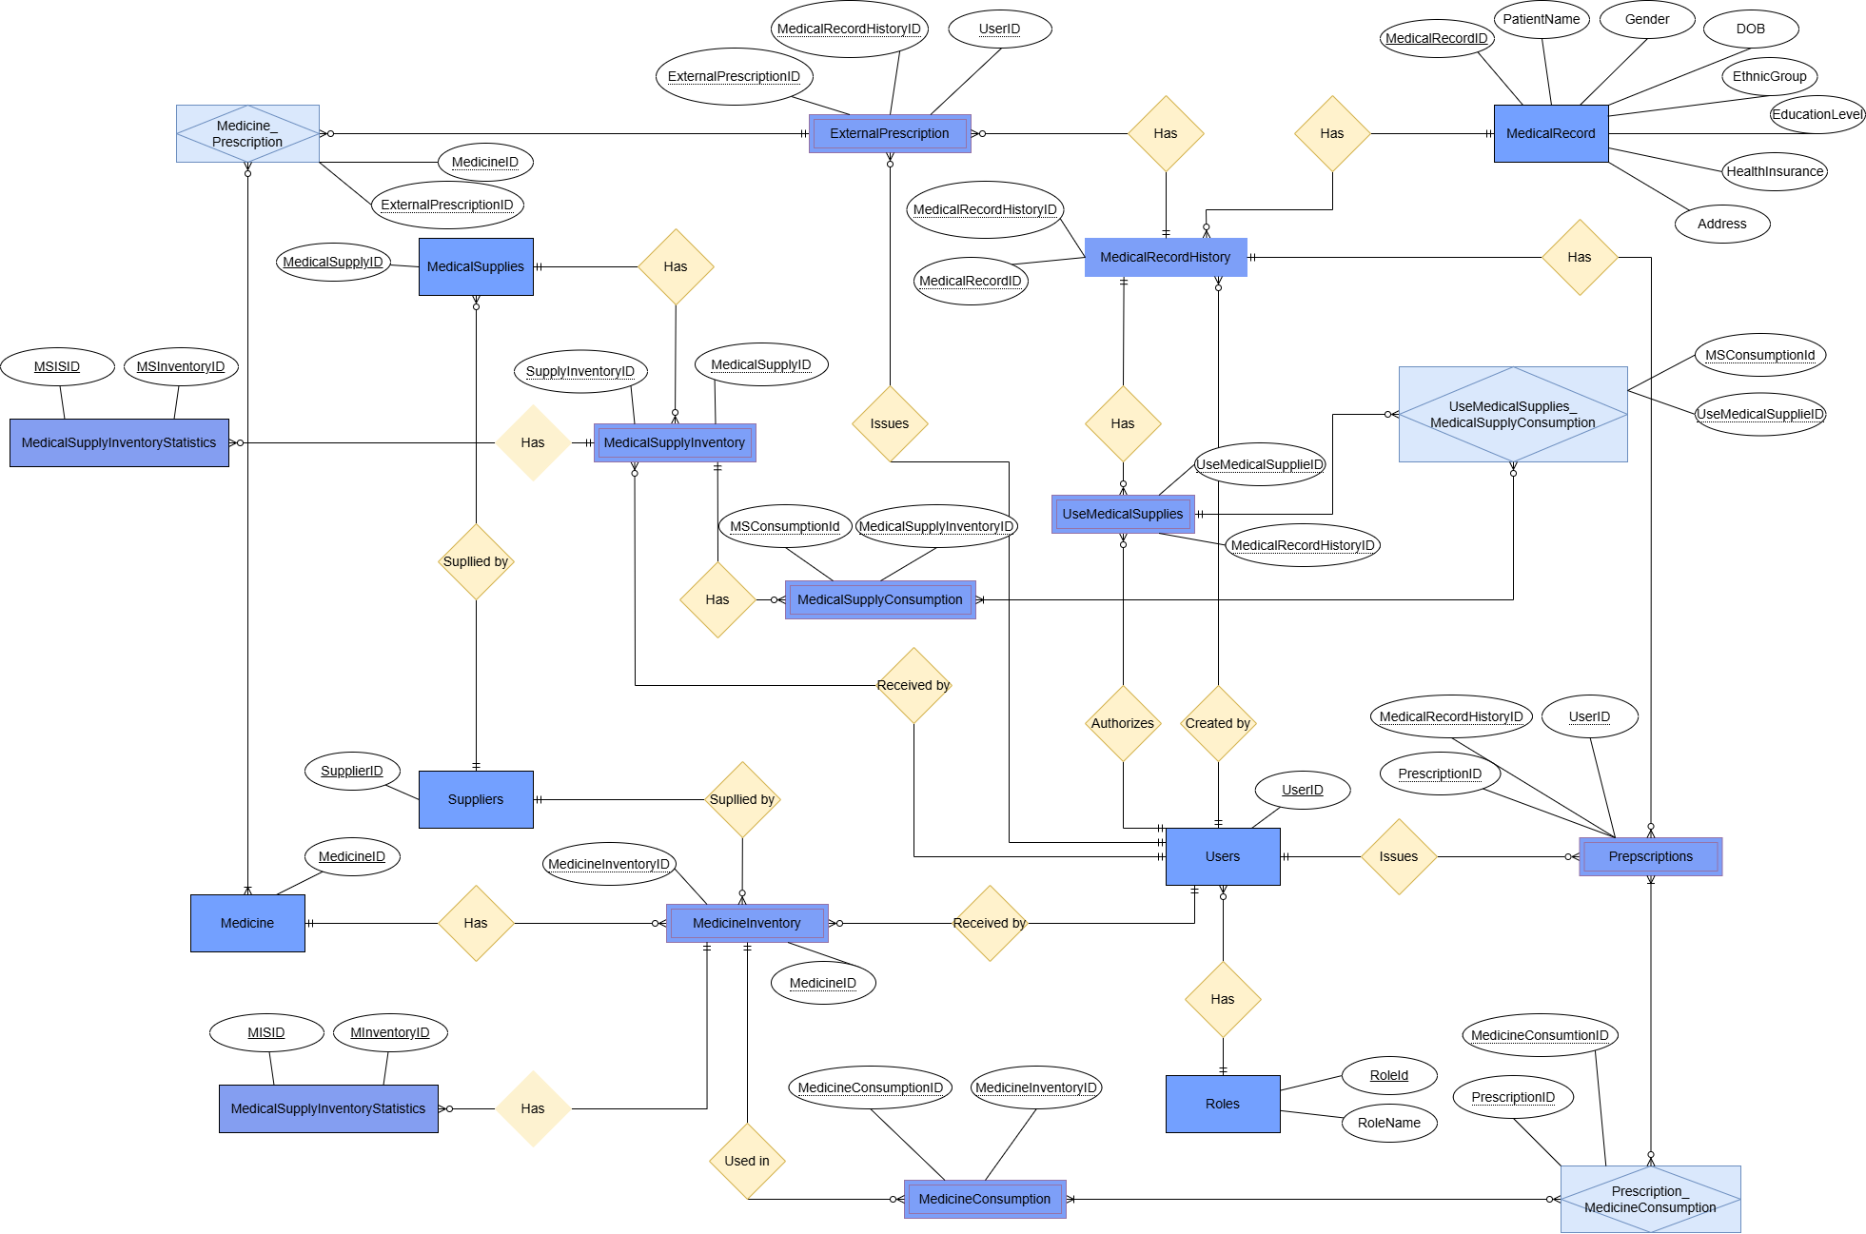

*Figure 14– Entity Relationship Diagram*

**Entities Description**

| **#** | **Entity** | **Description** |
| --- | --- | --- |
| 1 | Role | Stores user role information with RoleID and RoleName |
| 2 | Users | Contains user account details including credentials and contact information |
| 3 | MedicalRecord | Stores patient medical information including personal details and health insurance |
| 4 | MedicalRecordHistory | Contains medical visit records including vital signs and diagnoses |
| 5 | UsedMedicalSupplies | Tracks medical supplies used during treatments |
| 6 | Prescriptions | Stores prescription information issued to patients |
| 7 | ExternalPrescription | Records prescriptions from external providers |
| 8 | MedicalSupplies | Contains inventory of medical supplies with details and pricing |
| 9 | MedicalSupplyInventory | Tracks medical supplies stock levels and transaction details |
| 10 | MedicalSupplyConsumption | Records usage of medical supplies |
| 11 | MedicineConsumption | Tracks medicine usage details |
| 12 | Suppliers | Contains information about supply vendors |
| 13 | MedicineInventory | Tracks medicine stock levels and transaction details |
| 14 | Medicine | Stores medicine information including dosage forms and pricing |
| 15 | Medicine_Prescription | Maps relationships between medicines and prescriptions |
| 16 | UseMedicalSupplies_MedicalSupplyConsumption | Junction table for medical supplies usage |
| 17 | Prescription_MedicineConsumption | Junction table linking prescriptions and medicine usage |
| 18 | MedicineStatistic | View medicine statistic |
| 19 | MedicalSupplyStatistic | View medical supply statistic |

*Table6– Entities Description*

## 2. Use Case Specifications

### 2.1 User

#### 2.1.1 Login System

| Primary Actors | User | Secondary Actors | None |
| --- | --- | --- | --- |
| Description | As a user, I want to be able to log into the system so that I can use the system’s authenticated features and access my personalized account. | | |
| Preconditions | PRE-01: User account has been created & authorized | | |
| Postconditions | POST-01: User logs in the system successfully | | |
| Normal Sequence/Flow | ***Login System***   1. User clicks Login button in an unauthenticated page or accesses an authenticated feature (from a link or type the page URL directly into the address bar) 2. System show the User Login screen 3. User types in the login details (username, password) 4. User clicks the Login button 5. System validates the login details 6. System allows user to access 7. System directs user to the Home Page (or the previous calling page if any) | | |
| Alternative Sequences/Flows | ***Step 4_System can’t authenticate the user***  4.1 User can’t be authenticated & get relevant error message in one of below cases   1. He/she leaves the Email and/or Password field blank 2. Input Email or Password are incorrect 3. The user account is blocked / inactive   4.2 Return to step 3 | | |
| Business Rules | BR1,BR2 | | |
| System Messages | MSG1,MSG2,MSG3 | | |

*Table 7– Login System Use Case Specifications*

#### 2.1.2 Reset password

| Primary Actors | User | Secondary Actors | None |
| --- | --- | --- | --- |
| Description | As a user, I want to be able to reset my password in case I forgot or someone change my password | | |
| Preconditions | PRE-01: User account has been created & authorized PRE-02: The user must have access to the email associated with the account. | | |
| Postconditions | POST-01: The user’s password is successfully updated.  POST-02: The reset token is invalidated.  POST-03: The user can log in using the new password. | | |
| Normal Sequence/Flow | ***Reset password***   1. User clicks forgot password button in the login page 2. System show the Reset Password screen 3. The user enters their registered email address. 4. User clicks the Reset Password button 5. System validates the email and generates a password reset token (BR-03). 6. The system sends a password reset email containing a unique link to the user. 7. The user clicks the link in the email, which redirects them to the password reset page. 8. The user enters a new password and confirms it. 9. The system validates the password (length, complexity) and updates it in the database . 10. The system invalidates the reset token. 11. The system notifies the user that the password reset was successful. 12. The user can now log in using the new password. | | |
| Alternative Sequences/Flows | ***Step 4_Invalid Email Address*** 4.1 The system displays a message to inform that the email is not valid or not exist.  4.2 Return to step 3 ***Step 8_Invalid token or password***  8.1 The password will not be change & get relevant error message in one of below cases   1. He/she leaves the New Password and/or Retype Password field blank 2. The password does not have the appropriate length or complexity 3. The token is invalid or expired   8.2 Return to step 7 | | |
| Business Rules | BR-03,BR-04,BR-05 | | |
| System Messages | MSG04,MSG05,MSG06,MSG07,MSG08,MSG09,MSG10 | | |

*Table 8– Reset Password Use Case Specifications*

#### 2.1.3 User Profile

| Primary Actors | User | Secondary Actors | None |
| --- | --- | --- | --- |
| Description | As a user, I want to be able to see and change information of my user profile | | |
| Preconditions | PRE-01: User account has been created & authorized PRE-02: User is authenticated | | |
| Postconditions | POST-01: The user’s profile information is successfully updated. | | |
| Normal Sequence/Flow | **User Profile**   1. User clicks user profile in the header 2. The system retrieves and displays the user’s current profile information. 3. The user click edit profile 4. The page update to enable the user to change profile information 5. The user updates profile details (phone number, email, address). 6. User clicks the update button 7. The system updates the user profile | | |
| Alternative Sequences/Flows | ***Step 5_Invalid Input Data***  4.1 The system displays a message to inform that the information input is empty or not valid  4.2 Return to step 4 | | |
| Business Rules | BR-06,BR-07,BR-08,BR-09 | | |
| System Messages | MSG11,MSG12,MSG13,MSG14,MSG15 | | |

*Table 10– User Profile Use Case Specifications*

#### 2.1.4 View user list

| Primary Actors | Admin | Secondary Actors | None |
| --- | --- | --- | --- |
| Description | As a admin, I want to be able to see and manage user | | |
| Preconditions | PRE-01: User account has been created & authorized PRE-02: User is logged in with a admin account | | |
| Postconditions | POST-01: The user list is displayed successfully. | | |
| Normal Sequence/Flow | ***View user list***   1. User clicks user management in the header 2. The system displays the user list with relevant details (name, username, email, phone number, address) 3. The admin can deactivate or add new user | | |
| Alternative Sequences/Flows |  | | |
| Business Rules | BR-10,BR-11,BR-12 | | |
| System Messages | MSG34 | | |

#### 

*Table 11– View user list Use Case Specifications*

#### 2.1.5 Change User Status

| Primary Actors | Admin | Secondary Actors | None |
| --- | --- | --- | --- |
| Description | As an admin, I want to be able to deactivate accounts that I don’t want to be able to access the system and re-active deactivated accounts | | |
| Preconditions | PRE-01: User account has been created & authorized PRE-02: User is logged in with a admin account | | |
| Postconditions | POST-01: Active user will be marked as inactive and can no longer log in.  POST-02: Inactive user will be marked as active and can log in again | | |
| Normal Sequence/Flow | ***Change User Status***   1. The admin access the user list 2. The system retrieves and displays the user’s current profile information. 3. The admin selects a specific user and chooses the active or deactivate option. 4. The system prompts for confirmation. 5. Upon confirmation, the system updates the user’s status. 6. The system notifies the admin that the deactivation was successful. | | |
| Alternative Sequences/Flows |  | | |
| Business Rules | BR-11,BR-12 | | |
| System Messages | MSG16,MSG17,MSG18 | | |

*Table 12– Change User Status Use Case Specifications*

#### 2.1.6 Add User

| Primary Actors | Admin | Secondary Actors | None |
| --- | --- | --- | --- |
| Description | As a user, I want to be able to add new account for other people to access the system | | |
| Preconditions | PRE-01: User account has been created & authorized PRE-02: User is logged in with a admin account | | |
| Postconditions | POST-01: The new user is successfully added to the system.  POST-02: The user receives login credentials via email. | | |
| Normal Sequence/Flow | ***User Profile***   1. The admin access the user list 2. The admin click the add user 3. The system displays a pop-up for the admin to input the information of the user 4. The admin enters the new user’s details (name, username, email, phone number, address) 5. The user click add user 6. The system notifies the admin of the successful creation. 7. A email is sent to the user contain the username and password of the new user | | |
| Alternative Sequences/Flows | ***Step 5_Invalid Input Data***  4.1 The system displays a message to inform that the information input is empty or not valid  4.2 Return to step 4 | | |
| Business Rules | BR-14,BR-15 | | |
| System Messages | MSG18,MSG19,MSG20,MSG21 | | |

*Table 13– Add User Use Case Specifications*

#### 2.1.7 Change password

| Primary Actors | User | Secondary Actors | None |
| --- | --- | --- | --- |
| Description | As a user, I want to be able to see and change my password | | |
| Preconditions | PRE-01: User account has been created & authorized PRE-02: User is authenticated | | |
| Postconditions | POST-01: The user’s password is successfully updated. | | |
| Normal Sequence/Flow | User Profile   1. User clicks user profile in the header 2. The system retrieves and displays the user’s current profile information. 3. The user click change password 4. The page redirect to change password page 5. The user input old and new passwords. 6. User clicks the update button 7. The system updates the user password | | |
| Alternative Sequences/Flows | ***Step 5_Invalid Input Data***  4.1 The system displays a message to inform that the information input is empty or not valid  4.2 Return to step 4 | | |
| Business Rules | BR-16,BR-17,BR-18 | | |
| System Messages | MSG09,MSG22,MSG23,MSG24 | | |

*Table 14– Change Password Use Case Specifications*

### 2.2 Medicine

#### 2.2.1 View medicine list

#### 

| Primary Actors | Pharmacist | Secondary Actors | None |
| --- | --- | --- | --- |
| Description | As a pharmacist, I want to be able to view the list of medicines in the system so that I can check the current inventory and find medicine information. | | |
| Preconditions | PRE-01: Pharmacist has logged into the system | | |
| Postconditions | POST-01: Pharmacist views the medicine list | | |
| Normal Sequence/Flow | ***View Medicine List***   1. Pharmacist navigates to the Medicine Management section 2. System receive data from database and displays the Medicine List to screen | | |
| Alternative Sequences/Flows | Step 2_No medicines found  2.1 If no medicines exist in the system  2.2 System displays an appropriate message indicating no medicines found (e.g., "No medicines available in the system") | | |
| Business Rules | BR-19 | | |
| System Messages | MSG34 | | |

*Table 15– View medicine list Use Case Specifications*

#### 2.2.2 View consume medicine history

#### 

| Primary Actors | Pharmacist | Secondary Actors | None |
| --- | --- | --- | --- |
| Description | As a pharmacist, I want to be able to view the consumption history of medicines so that I can track usage patterns, monitor inventory changes, and generate reports. | | |
| Preconditions | PRE-01: Pharmacist has logged into the system | | |
| Postconditions | POST-01: Pharmacist views the medicine consumption history | | |
| Normal Sequence/Flow | ***View Consume Medicine History***  1. Pharmacist navigates to the View medicine consumption history Button  2. Pharmacist selects "View medicine consumption history" button  3. System retrieves data from database and displays the medicine consumption history on screen  4. The history shows details such as medicine name, quantity consumed, date of consumption | | |
| Alternative Sequences/Flows | Step 3_No consumption history found  3.1 If no consumption history exists in the system  3.2 System displays an appropriate message indicating no consumption history found (e.g., "No medicine consumption history available") | | |
| Business Rules |  | | |
| System Messages |  | | |

*Table 16– View consume medicine history Use Case Specifications*

#### 2.2.3 Add medicine to Inventory

#### 

| Primary Actors | Pharmacist | Secondary Actors | None |
| --- | --- | --- | --- |
| Description | As a pharmacist, I want to be able to add new medicines to the inventory system so that I can keep track of newly acquired medications and maintain an accurate inventory. | | |
| Preconditions | PRE-01: Pharmacist has logged into the system  PRE-02: Medicine information is available (name, code, category, quantity, expiration date, etc.) | | |
| Postconditions | POST-01: Medicine is successfully added to the inventory system | | |
| Normal Sequence/Flow | ***Add Medicine to Inventory***   1. Pharmacist navigates to the Medicine Management section 2. Pharmacist selects "Add Medicine to Inventory" button 3. System transfer user to the Add Medicine page 4. Pharmacist enters the required medicine details in Batch Form:   - Medicine’s Batch number  - Medicine’s Certificate number  - Medicine’s Transaction Date  - Medicine’s Transaction Type  - Medicine’s Suppliers   1. Pharmacist click button submit Medicine batch 2. System validate batch form 3. Pharmacist navigates to the add medicine to batch 4. Pharmacist enters the required medicine details in Add Medicine Form:   - Import Quantity  - Manufacture Date  - Medicine Name  - Note(optional)   1. Pharmacist submits the form 2. System validates the entered data 3. System record entered data and send to the final form 4. Pharmacist press submit batch 5. System saves the medicine information to the database 6. System displays a success message 7. System updates the inventory count | | |
| Alternative Sequences/Flows | Step 6_Batch Form Validation Failure  6.1 System detects invalid or missing required information in the Batch Form  6.2 System displays appropriate error messages  6.3 Pharmacist corrects the information  6.4 Return to step 5  Step 10_Add Medicine Form Validation Failure  10.1 System detects invalid or missing required information in the Add Medicine Form  10.2 System displays appropriate error messages  10.3 Pharmacist corrects the information  10.4 Return to step 9  Step 13_Database Storage Failure  13.1 System encounters an error saving the medicine information to the database  13.2 System displays an error message  13.2 System prompts the pharmacist to try again  13.3 Return to step 12  Step 8_Duplicate Medicine Entry  8.1 System detects that medicine with the same batch number already exists  8.2 System displays a warning message  8.3 Pharmacist can either modify the batch number or confirm to continue with the existing one  8.4 Return to appropriate step based on pharmacist's decision | | |
| Business Rules | BR-20,BR-21,BR-22 | | |
| System Messages | MSG25,MSG26,MSG27,MSG28,MSG29,MSG30,MSG31 | | |

*Table 17– Add Medicine to inventory Use Case Specifications*

#### 2.2.4 Update Medicine in Inventory

#### 

| Primary Actors | Pharmacist | Secondary Actors | None |
| --- | --- | --- | --- |
| Description | As a pharmacist, I want to be able to update existing medicine information in the inventory system so that I can correct errors, update quantities, and maintain accurate records. | | |
| Preconditions | PRE-01: Pharmacist has logged into the system  PRE-02: Medicine to be updated exists in the inventory system | | |
| Postconditions | POST-01: Medicine information is successfully updated in the inventory system | | |
| Normal Sequence/Flow | ***Update Medicine in Inventory***   1. Pharmacist navigates to the Medicine Management section 2. Pharmacist selects "Add Medicine to Inventory" button 3. System transfer user to the Add Medicine page 4. System displays the all the medicine had added 5. Pharmacist locates the medicine to be updated 6. Pharmacist selects the medicine and clicks "Edit" button 7. System turn row to editable row 8. Pharmacist modifies the relevant fields (quantity, manufacture date, note) 9. Pharmacist submits 10. System validates the entered data 11. System updates the medicine information in the database 12. System displays a success message | | |
| Alternative Sequences/Flows | Step 8_Validation Failure  8.1 System detects invalid or missing required information  8.2 System displays appropriate error messages  8.3 Pharmacist corrects the information  8.4 Return to step 7  Step 9_Database Update Failure  9.1 System encounters an error updating the medicine information  9.2 System displays an error message  9.3 System allows pharmacist to retry or cancel the operation  9.4 Return to appropriate step based on pharmacist's decision | | |
| Business Rules | BR-23 | | |
| System Messages | MSG32 | | |

*Table 18– Update Medicine in inventory Use Case Specifications*

#### 2.2.5 View added medicine list history

#### 

| Primary Actors | Pharmacist | Secondary Actors | None |
| --- | --- | --- | --- |
| Description | As a pharmacist, I want to be able to view the history of medicines added to the inventory system so that I can track when and how medicines were acquired and maintain an audit trail of inventory additions. | | |
| Preconditions | PRE-01: Pharmacist has logged into the system | | |
| Postconditions | POST-01: Pharmacist views the history of added medicines | | |
| Normal Sequence/Flow | ***View Added Medicine List History***  1. Pharmacist navigates to the Medicine Management section  2. Pharmacist selects "Add Medicine to Inventory" button  3. System transfer user to the Add Medicine page  4. System retrieves data from database and displays the history of medicine additions  5. The history includes details such as:  - Medicine name  - Batch number  - Quantity added  - Addition date  - Supplier information  - Transaction details  6. Pharmacists can filter medicine by date  7. Pharmacist can export the history to a printable report or spreadsheet if needed | | |
| Alternative Sequences/Flows | Step 3_No medicines found  3.1 If no medicines exist in the system  3.2 System displays an appropriate message indicating no medicines found (e.g., "No medicines available in the system" | | |
| Business Rules | BR-24,BR-25,BR-26 | | |
| System Messages | MSG33 | | |

*Table 19– View added list medicine list history Use Case Specifications*

#### 2.2.6 Search medicine

#### 

| Primary Actors | Pharmacist | Secondary Actors | None |
| --- | --- | --- | --- |
| Description | As a pharmacist, I want to be able to search for medicines in the system using various criteria (such as name, category, manufacturer) so that I can quickly find specific medicines and view their information. | | |
| Preconditions | PRE-01: Pharmacist has logged into the system | | |
| Postconditions | POST-01: Pharmacist views the search results of medicines matching the search criteria | | |
| Normal Sequence/Flow | ***Search Medicine***   1. Pharmacist navigates to the Medicine Management section 2. Pharmacist selects the Search function 3. System displays the search interface with various filter options (name, category, manufacturer, etc.) 4. Pharmacist enters search criteria in one or more search fields 5. System queries the database based on the provided search criteria 6. System displays a list of medicines matching the search criteria | | |
| Alternative Sequences/Flows | Step 3_No medicines found  6.1. If no medicines match the search criteria  6.2. System displays an appropriate message indicating no medicines found (e.g., "No medicines match your search criteria")  6.3. System provides options to modify search criteria or return to the main medicine list | | |
| Business Rules | BR-27 | | |
| System Messages | MSG33 | | |

*Table 20– Search medicine Use Case Specifications*

#### 2.2.7 View medicine Prescription history

| Primary Actors | Pharmacist | Secondary Actors | None |
| --- | --- | --- | --- |
| Description | As a pharmacist, | | |
| Preconditions | PRE-01: Pharmacist has logged into the system  PRE-02: Medicine prescription data is available in the system | | |
| Postconditions | POST-01: Pharmacist views the medicine prescription | | |
| Normal Sequence/Flow | ***View Medicine List***   1. Pharmacist navigates to the Reports section in the Medicine Management module 2. Pharmacist selects "Lịch sử xuất thuốc" option 3. System displays configuration options (patient info, health insurance, doctor name, note, etc.) 4. (Optional) Pharmacist view prescription detail by press detail action | | |
| Alternative Sequences/Flows |  | | |
| Business Rules | BR-19 | | |
| System Messages | MSG34 | | |

#### 

*Table 21– View Medicine Prescription History Use Case Specifications*

### 2.3 Medical Supply

#### 2.3.1 View Medical Supplies Inventory

| Primary Actors | Pharmacist | Secondary Actors | CHSMS System |
| --- | --- | --- | --- |
| Description | Pharmacists perform an inventory check to validate actual medical supply stock against system records. | | |
| Preconditions | PRE-01: Inventory items are available.  PRE-01: Pharmacist is authorized to perform inventory. | | |
| Postconditions | POST-01: Actual counts are updated in the system.  POST-01: An inventory history record is generated. | | |
| Normal Sequence/Flow | 1. Pharmacist selects "Quản lý vật tư".  2. System displays a list of supplies. | | |
| Alternative Sequences/Flows | - If discrepancies are found, the pharmacist reports and adjusts records as per protocol. | | |
| Business Rules |  | | |
| System Messages | MSG34 | | |

*Table 22– View Medical Supplies Inventory Use Case Specifications*

#### 2.3.2 View Medical Supplies Consumption History

| Primary Actors | Pharmacist | Secondary Actors | CHSMS System |
| --- | --- | --- | --- |
| Description | Pharmacist reviews medical supplies usage history records. | | |
| Preconditions | PRE-01: Past inventory records exist. | | |
| Postconditions | POST-01: Pharmacist views detailed logs of previous inventories. | | |
| Normal Sequence/Flow | 1. Pharmacist selects "Quản lý vật tư".  2. Pharmacist selects "Từ ngày" và “Đến ngày”  3. Pharmacist selects “Lịch sử tiêu thụ” | | |
| Alternative Sequences/Flows | - If no history exists, system displays "No records found". | | |
| Business Rules |  | | |
| System Messages | MSG34 | | |

#### 

*Table 23– View Medical Supplies Consumption History Use Case Specifications*

#### 2.3.3 View Medical Supplies Consumption Report

| Primary Actors | Pharmacist | Secondary Actors | CHSMS System |
| --- | --- | --- | --- |
| Description | Pharmacists view reports on the quantity of medical supplies received, used, and stock. | | |
| Preconditions | PRE-01: Supply data is available in the system. | | |
| Postconditions | POST-01: Detailed information is shown to the pharmacist. | | |
| Normal Sequence/Flow | 1. Pharmacist selects "Quản lý vật tư".  2. Pharmacist selects "Báo cáo xuất nhập tồn” | | |
| Alternative Sequences/Flows | - If medical supply item is missing, system shows an error message. | | |
| Business Rules |  | | |
| System Messages | MSG34 | | |

#### 

*Table 24– View Medical Supplies Consumption Report Use Case Specifications*

#### 2.3.4 Consume Medical Supply

| Primary Actors | Pharmacist | Secondary Actors | CHSMS System |
| --- | --- | --- | --- |
| Description | Pharmacist views historical dispensing records of medical supplies to patients. | | |
| Preconditions | PRE-01: Medical supply exists. | | |
| Postconditions | POST-01: Pharmacist successfully views dispensing history. | | |
| Normal Sequence/Flow | 1. Pharmacist selects "Quản lý vật tư".  2. Pharmacist selects "Xuất Vật tư”  3. Pharmacist selects medical supplies by medical supply and batch numbenn 4. Pharmacist enters quantity of supplies used | | |
| Alternative Sequences/Flows | - If no records exist, system shows an empty list with a notification. | | |
| Business Rules | BR-30, BR-31, BR-32 | | |
| System Messages | MSG37 | | |

*Table 25– Consume Medical Supply Use Case Specifications*

#### 

#### 

#### 2.3.5 View Added Medicine to Inventory History

| Primary Actors | Pharmacist | Secondary Actors | CHSMS System |
| --- | --- | --- | --- |
| Description | Pharmacist views the history of added medical supplies to the inventory. | | |
| Preconditions | PRE-01: Additions have been made previously. | | |
| Postconditions | POST-01: Pharmacist views addition history successfully. | | |
| Normal Sequence/Flow | 1. Pharmacist selects "Quản lý vật tư".  2. Pharmacist selects "Từ ngày" và “Đến ngày”  3. Pharmacist selects “Lịch sử nhập vật tư” | | |
| Alternative Sequences/Flows | - If no history exists, system displays a message: "No addition records found". | | |
| Business Rules |  | | |
| System Messages | MSG34 | | |

#### 

*Table 26– View Added Medicine to Inventory Use Case Specifications*

#### 2.3.6 Add Medical Supply to Inventory

| Primary Actors | Pharmacist | Secondary Actors | CHSMS System |
| --- | --- | --- | --- |
| Description | Pharmacist adds new stock of medical supplies to the system. | | |
| Preconditions | PRE-01: Pharmacist has permission to add supplies.  PRE-02: Supplies are physically received. | | |
| Postconditions | POST-01: Supplies are added to inventory.  POST-02: Inventory levels are updated.  POST-03: Addition history is created. | | |
| Normal Sequence/Flow | 1. Pharmacist selects "Add Medical Supply".  2. Inputs supply details (name, quantity, batch number, etc.).  3. System saves and updates inventory. | | |
| Alternative Sequences/Flows | - If mandatory fields are missing, system prompts for completion. | | |
| Business Rules | BR-26, BR-27, BR-28, BR-29, BR-30. | | |
| System Messages | MSG35, MSG36 | | |

*Table 27– Add Medical Supply to Inventory Use Case Specifications*

### 2.4 Medical Record

#### 2.4.1 View Medical Record List

#### 

| Primary Actors | Doctor | Secondary Actors | CHSMS System |
| --- | --- | --- | --- |
| Description | Doctor views a list of all patients' medical records in the system. | | |
| Preconditions | PRE-01: Doctor is logged into the system.  PRE-02: Medical records exist. | | |
| Postconditions | POST-01: Medical record list is displayed. | | |
| Normal Sequence/Flow | 1. Doctor selects "View Medical Record List".  2. System retrieves and displays the list. | | |
| Alternative Sequences/Flows | - If no records exist, the system displays "No medical records found". | | |
| Business Rules | BR-33 | | |
| System Messages | MSG34 | | |

#### 

*Table 28– View Medical Record List Use Case Specifications*

#### 2.4.2 View Medical Record History List Today

| Primary Actors | Doctor | Secondary Actors | CHSMS System |
| --- | --- | --- | --- |
| Description | User views a personal history list of their own medical records. | | |
| Preconditions | PRE-01: User is logged in.  PRE-02: User has medical record history. | | |
| Postconditions | POST-01: Medical record history list today is displayed. | | |
| Normal Sequence/Flow | 1. User accesses "View Medical Record History List Today".  2. System shows relevant history. | | |
| Alternative Sequences/Flows | - If no history exists, system shows a notification. | | |
| Business Rules | BR-33 | | |
| System Messages | MSG34 | | |

#### 

*Table 29– View Medical Record List Today Use Case Specifications*

#### 2.4.3 View Personal Medical Record History List

| Primary Actors | Doctor | Secondary Actors | CHSMS System |
| --- | --- | --- | --- |
| Description | User views a personal history list of their own medical records. | | |
| Preconditions | PRE-01: User is logged in.  PRE-02: User has medical record history. | | |
| Postconditions | POST-01: Personal medical record history list is displayed. | | |
| Normal Sequence/Flow | 1. User accesses "View Personal Medical Record History List".  2. System shows relevant history. | | |
| Alternative Sequences/Flows | - If no history exists, system shows a notification. | | |
| Business Rules | BR-33 | | |
| System Messages | MSG34 | | |

*Table 30– View Personal Medical Record History List Use Case Specifications*

#### 

#### 

#### 2.4.4 Search Medical Record by Name and Health Insurance

| Primary Actors | Doctor | Secondary Actors | CHSMS System |
| --- | --- | --- | --- |
| Description | Doctor searches for a medical record by entering a patient's name and health insurance. | | |
| Preconditions | PRE-01: Medical records exist.  PRE-02: Search function is available. | | |
| Postconditions | POST-01: Matching medical records are displayed. | | |
| Normal Sequence/Flow | 1. Doctor enters a patient's name or health insurance.  2. System searches and displays results. | | |
| Alternative Sequences/Flows | - If no matches found, system shows "No records found". | | |
| Business Rules | BR-33 | | |
| System Messages | MSG34 | | |

*Table 31– Search Medical Record by Name and Health Insurance Use Case Specifications*

#### 2.4.5 View Medical Record History Detail

| Primary Actors | Doctor | Secondary Actors | CHSMS System |
| --- | --- | --- | --- |
| Description | Doctor or user views detailed information about a specific medical record history. | | |
| Preconditions | PRE-01: History record exists. | | |
| Postconditions | POST-01: Details are displayed. | | |
| Normal Sequence/Flow | 1. Select a record from medical record list.  2. System displays detailed personal medical record history.  3. User select drop down list and click detail  4. System show detail medical record of that person | | |
| Alternative Sequences/Flows | - If record missing, system shows an error. | | |
| Business Rules | BR-33 | | |
| System Messages |  | | |

#### 

*Table 32– View Medical Record History Detail Use Case Specifications*

#### 2.4.6 Filter Medical Record History

| Primary Actors | Doctor | Secondary Actors | CHSMS System |
| --- | --- | --- | --- |
| Description | Doctor or user filters medical record history based on specific criteria (date, department, etc.). | | |
| Preconditions | PRE-01: Medical history data exists. | | |
| Postconditions | POST-01: Filtered results are displayed. | | |
| Normal Sequence/Flow | 1. Doctor/User applies filters by date or by doctor’s name.  2. System shows filtered history. | | |
| Alternative Sequences/Flows | - No matching records are found. | | |
| Business Rules | BR-33 | | |
| System Messages |  | | |

#### 

*Table 33– Filter Medical Record History Use Case Specifications*

#### 2.4.7 Create Medical Record

| Primary Actors | Doctor | Secondary Actors | CHSMS System |
| --- | --- | --- | --- |
| Description | Doctor create new medical records for patient. | | |
| Preconditions | PRE-01: Doctor is logged in.  PRE-02: Necessary patient information is available. | | |
| Postconditions | POST-01: New medical record entries are created. | | |
| Normal Sequence/Flow | 1. Doctor fills in patient information.  2. Doctor submits the form.  3. System saves the new record.  4. System displays a success message and close create form back to the medical record list | | |
| Alternative Sequences/Flows | Step 1: Invalid credential:   1. Input wrong type of format   1.1. System show error message to warning input again   1. Leave input field blank   2.2. System show error message to warning input again | | |
| Business Rules | BR-33, BR-34 | | |
| System Messages | MSG38, MSG39 | | |

#### 

*Table 34– Create Medical Record Use Case Specifications*

#### 2.4.8 Create Use Medical Supply

| Primary Actors | Doctor | Secondary Actors | CHSMS System |
| --- | --- | --- | --- |
| Description | Doctor records the use of medical supplies for patient treatment. | | |
| Preconditions | PRE-01: Doctor is logged in.  PRE-02: Medical supplies data is available. | | |
| Postconditions | POST-01: New use medical supply record is created. | | |
| Normal Sequence/Flow | 1. Doctor click button ”Thêm vật tư” for medical supplies used.  2. System show form to choose medical supply  3. Doctor enter medical supply’s name, quantity and reason.  4. Doctor click save “Thêm” button  5. System close form and back to “Phiếu sử dụng vật tư” form  6. Doctor input note for use medical supply form  7. Doctor click button “Tạo đơn vật tư”  8. System saves the usage record. | | |
| Alternative Sequences/Flows | Step 3: Input invalid credential   * Quantity < 0 or > quantity in inventory * System show error message * The user is prompted to correct the input before proceeding.   Step 6: Leave note input field bank   * System show error inline * The user is prompted to correct the input before proceeding. | | |
| Business Rules | BR-33, BR-34 | | |
| System Messages | MSG30, MSG40  MSG41, MSG42 | | |

*Table 35– Create Use Medical Supply Use Case Specifications*

#### 2.4.9 Edit Medical Record History

| Primary Actors | Doctor | Secondary Actors | CHSMS System |
| --- | --- | --- | --- |
| Description | The doctor edits an existing medical record history entry for a patient, updating details such as diagnosis, treatment notes, or other relevant information. | | |
| Preconditions | PRE-01: User is logged in as a Doctor.  PRE-02: User has access to the patient’s medical record history.  PRE-03: The medical record history entry exists and is editable. | | |
| Postconditions | POST-01: The medical record history entry is updated with the new information.  POST-02: The system logs the edit action for audit purposes. | | |
| Normal Sequence/Flow | 1. The Doctor accesses the "View Medical Record History" or "View Today’s Medical History" feature.  2. The System displays the list of medical record history entries for the selected patient or date.  3. The Doctor selects a specific medical record history entry to edit.  4. The System displays the editable details of the selected entry (e.g., diagnosis, treatment notes).  5. The Doctor updates the necessary fields and submits the changes.  6. The System validates the input data (e.g., ensures required fields are filled, data formats are correct).  7. The System saves the updated medical record history entry.  8. The System displays a confirmation message indicating the update was successful. | | |
| Alternative Sequences/Flows | - If the medical record history exceeds 1 day, the user can not edit.  - If the input data is invalid (e.g., missing required fields), the System displays an error message and prompts the Doctor to correct the input. | | |
| Business Rules | BR-33, BR-35, BR34 | | |
| System Messages | MSG38, MSG43 | | |

*Table – Edit Medical Record History Use Case Specifications*

#### 2.4.9 View Use Medical Supply List

| Primary Actors | Doctor | Secondary Actors | CHSMS System |
| --- | --- | --- | --- |
| Description | Doctor views a list of all recorded medical supply usage. | | |
| Preconditions | PRE-01: Doctor is logged in.  PRE-02: Usage records exist. | | |
| Postconditions | POST-01: Use medical supply list is displayed. | | |
| Normal Sequence/Flow | 1. Doctor selects "Chi tiết phiếu sử dụng vật tư".  2. System retrieves and displays the list. | | |
| Alternative Sequences/Flows | - If no records, system displays "No usage found". | | |
| Business Rules | BR-33 | | |
| System Messages |  | | |

*Table 34– View Use Medical Supply List Use Case Specifications*

#### 2.4.10 Edit Use Medical Supply

| Primary Actors | Doctor | Secondary Actors | CHSMS System |
| --- | --- | --- | --- |
| Description | Doctor edits details of a recorded medical supply usage. | | |
| Preconditions | PRE-01: Use medical supply record exists. | | |
| Postconditions | POST-01: Edited record is updated. | | |
| Normal Sequence/Flow | 1. Doctor click button ”Sửa” for medical supplies used.  2. (optional) Doctor click button ”Thêm vật tư mới” for medical supplies used.  3. (optional)System show form to choose medical supply  4. (optional)Doctor enter medical supply’s name, quantity and reason.  5. (optional)Doctor click save “Thêm” button  6. (optional) System close form and back to “Phiếu sử dụng vật tư” form  7. Doctor edit input note for use medical supply form  8. Doctor click button “Lưu chỉnh sửa”  9. System saves the usage record. | | |
| Alternative Sequences/Flows | - If the record exceeds 24h, editing is disabled. | | |
| Business Rules | BR-33, BR-34, BR-35 | | |
| System Messages | MSG30, MSG40  MSG41, MSG42 | | |

#### 

*Table 35– Edit Use Medical Supply Use Case Specifications*

#### 2.4.11 View Use Medical Supply Detail

| Primary Actors | Doctor | Secondary Actors | CHSMS System |
| --- | --- | --- | --- |
| Description | Doctor views detailed information about a specific use of medical supply. | | |
| Preconditions | PRE-01: Usage record exists. | | |
| Postconditions | POST-01: Details are displayed. | | |
| Normal Sequence/Flow | 1. Doctor clicks on a specific usage record.  2. System shows detailed information. | | |
| Alternative Sequences/Flows | - If the record is deleted, system shows "Record not found". | | |
| Business Rules | BR-33 | | |
| System Messages |  | | |

*Table 36– View Use Medical Supply Detail*

### 2.5 Prescription

#### 2.5.1 View Prescriptions

| Primary Actors | Doctor | Secondary Actors | CHSMS System |
| --- | --- | --- | --- |
| Description | Doctor views a list of prescriptions created. | | |
| Preconditions | PRE-01: Prescriptions exist. | | |
| Postconditions | POST-01: Prescription list is displayed. | | |
| Normal Sequence/Flow | 1. Doctor accesses "View Prescriptions".  2. System lists all available prescriptions. | | |
| Alternative Sequences/Flows | - If no prescriptions, system shows an error inline. | | |
| Business Rules | BR-33 | | |
| System Messages | MSG34 | | |

#### 

*Table 37– View Prescription Use Case Specifications*

#### 2.5.2 Edit Prescription

| Primary Actors | Doctor | Secondary Actors | CHSMS System |
| --- | --- | --- | --- |
| Description | Doctor edits the details of a prescription. | | |
| Preconditions | PRE-01: Prescription exists.  PRE-02: Editing is allowed. | | |
| Postconditions | POST-01: Prescription is updated. | | |
| Normal Sequence/Flow | 1. Doctor click button ”Sửa” for medicine prescription.  2. (optional) Doctor click button ”Thêm thuốc mới” for medicine prescription.  3. (optional)System show form to choose medicine  4. (optional)Doctor enter medicine name, quantity and reason.  5. (optional)Doctor click save “Thêm” button  6. (optional) System close form and back to “Chỉnh sửa đơn thuốc” form  7. Doctor edit input note for medicine prescription form  8. Doctor click button “Lưu chỉnh sửa”  9. System saves the usage record. | | |
| Alternative Sequences/Flows | - If editing exceeds 24h, editing is disabled.  - If no medicine appear in medicine prescription  - System show error | | |
| Business Rules | BR-33, BR-34, BR-35 | | |
| System Messages | MSG30, MSG42, MSG44 | | |

#### 

*Table 38– Edit Prescription Use Case Specifications*

#### 2.5.3 View Prescription Detail

| Primary Actors | Doctor | Secondary Actors | CHSMS System |
| --- | --- | --- | --- |
| Description | Doctor views detailed information of a specific prescription. | | |
| Preconditions | PRE-01: Prescription exists. | | |
| Postconditions | POST-01: Prescription details are shown. | | |
| Normal Sequence/Flow | 1. Doctor selects a prescription.  2. System shows detailed information. | | |
| Alternative Sequences/Flows | - If record missing, error is shown. | | |
| Business Rules | BR-33 | | |
| System Messages | MSG34 | | |

#### 

*Table 39– View Prescription Detail Use Case Specifications*

#### 2.5.4 View External Prescription List

| Primary Actors | Doctor | Secondary Actors | CHSMS System |
| --- | --- | --- | --- |
| Description | Doctor views a list of prescriptions from external sources. | | |
| Preconditions | PRE-01: External prescriptions exist. | | |
| Postconditions | PRE-01: List of external prescriptions is displayed. | | |
| Normal Sequence/Flow | 1. Doctor selects "View External Prescription List".  2. System displays available external prescriptions. | | |
| Alternative Sequences/Flows | POST-01: If no external prescriptions, system shows a message. | | |
| Business Rules | BR-33 | | |
| System Messages | MSG34 | | |

#### 

*Table 40– View External Prescription List Use Case Specifications*

#### 2.5.5 Edit External Prescription

| Primary Actors | Doctor | Secondary Actors | CHSMS System |
| --- | --- | --- | --- |
| Description | Doctor edits the details of an external prescription. | | |
| Preconditions | PRE-01: External prescription exists. | | |
| Postconditions | POST-01: External prescription is updated. | | |
| Normal Sequence/Flow | 1. Doctor click button ”Sửa” for external medicine prescription.  2. (optional) Doctor click button ”Thêm thuốc mới” for external medicine prescription.  3. (optional)System show form to choose medicine  4. (optional)Doctor enter medicine name, quantity and reason.  5. (optional)Doctor click save “Thêm” button  6. (optional) System close form and back to “Chỉnh sửa đơn thuốc” form  7. Doctor edit input note for external medicine prescription form  8. Doctor click button “Lưu chỉnh sửa”  9. System saves the usage record. | | |
| Alternative Sequences/Flows | - If editing exceeds 24h, editing is disabled.  - If no medicine appear in external medicine prescription  - System show error | | |
| Business Rules | BR-33, BR-34, BR-35 | | |
| System Messages | MSG30, MSG42, MSG44 | | |

#### 

*Table 41– Edit External Prescription Use Case Specifications*

#### 2.5.6 View External Prescription Detail

| Primary Actors | Doctor | Secondary Actors | CHSMS System |
| --- | --- | --- | --- |
| Description | Doctor views detailed information of a specific external prescription. | | |
| Preconditions | PRE-01: External prescription exists. | | |
| Postconditions | POST-01: Details are displayed. | | |
| Normal Sequence/Flow | 1. Doctor selects button ”Tùy chọn” to show the drop down list function.  2. Doctor navigate to “Chi tiết đơn thuốc ngoài” function and clicked  3. System displays detailed external medicine prescriptions. | | |
| Alternative Sequences/Flows | - If no external medicine appear in external medicine detail  - System show error | | |
| Business Rules | BR-33 | | |
| System Messages | MSG34 | | |

#### 

*Table 42– View External Prescription Detail Use Case Specifications*

#### 2.5.7 Create Prescription

| Primary Actors | Doctor | Secondary Actors | CHSMS System |
| --- | --- | --- | --- |
| Description | Doctor creates a new prescription for a patient. | | |
| Preconditions | PRE-01: Patient information is available. | | |
| Postconditions | POST-01: New prescription is created and saved. | | |
| Normal Sequence/Flow | 1. Doctor selects button ”Tùy chọn” to show the drop down list function.  2. Doctor navigate to “Kê đơn thuốc” function and clicked  3. System displayed medicine prescription form  4. Doctor click button “Thêm thuốc” to add medicine to prescription  5. System show Add medicine form  4. Doctor fills medicine prescription form.  7. Doctor click “Thêm” button  8. System save medicine to prescription and close add medicine form  9. Doctor click “Tạo đơn thuốc” button.  10. System saves records and show create prescription success. | | |
| Alternative Sequences/Flows | - If fields are incomplete, the system requests completion.  - If no medicine added to medicine prescription, system show error | | |
| Business Rules | BR-33, BR-34 | | |
| System Messages | MSG30, MSG46, MSG47 | | |

#### 

*Table 43– Create Prescription Use Case Specifications*

#### 2.5.8 Create External Prescription

| Primary Actors | Doctor | Secondary Actors | CHSMS System |
| --- | --- | --- | --- |
| Description | Doctor creates a new external prescription for external patients. | | |
| Preconditions | PRE-01: External patient information is available. | | |
| Postconditions | POST-01: New external prescription is saved. | | |
| Normal Sequence/Flow | 1. Doctor selects button ”Tùy chọn” to show the drop down list function.  2. Doctor navigate to “Kê đơn thuốc ngoài” function and clicked  3. System displayed external medicine prescription form  4. Doctor click button “Thêm thuốc” to add medicine to prescription  5. System show Add medicine form  4. Doctor fills external medicine prescription form.  7. Doctor click “Thêm” button  8. System save medicine to prescription and close add medicine form  9. Doctor click “Tạo đơn thuốc” button.  10. System saves records and show create prescription success. | | |
| Alternative Sequences/Flows | - System notifies if missing critical data. | | |
| Business Rules | BR-33, BR-34 | | |
| System Messages | MSG30, MSG46, MSG48 | | |

#### 

*Table 44– Create External Prescription Use Case Specifications*

#### 2.5.9 View Medical Record History Today

| Primary Actors | Doctor | Secondary Actors | CHSMS System |
| --- | --- | --- | --- |
| Description | Doctor views the medical record activities (created, modified) that happened today. | | |
| Preconditions | PRE-01: There are activities today. | | |
| Postconditions | POST-01: Today's history is displayed. | | |
| Normal Sequence/Flow | 1. Doctor selects "View Medical Record History Today".  2. System retrieves today's data. | | |
| Alternative Sequences/Flows | - If no activity today, system shows "No medicine record today". | | |
| Business Rules | BR-33 | | |
| System Messages | MSG34 | | |

*Table 45– View Medical Record History Today Use Case Specifications*

## 3. Functional Requirements

### 3.1 User Authentication

#### 3.1.1 User Login

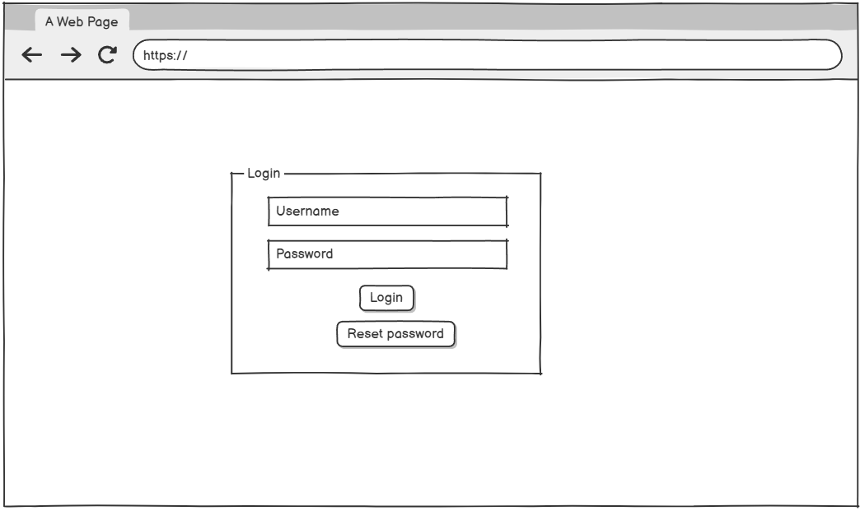

*Figure 15– User Login Mock Up*

###### 3.1.1.1 UI Requirement

| No. | Field Name | Field Type | Description |
| --- | --- | --- | --- |
| 1 | Username | Text Input | A field for the user to enter their username. |
| 2 | Password | Password Input | A field for the user to enter their password. |
| 3 | Sign In Button | Button | A button that triggers the sign-in process. |
| 4 | Reset Password link | Link | Opens screen to the reset password functionality. |

*Table 46– User login UI Requirement*

#### 3.1.2 Change Password

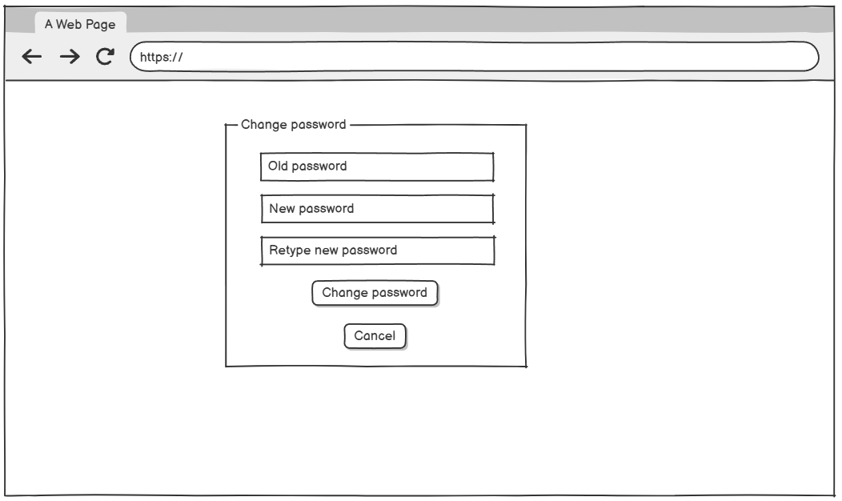

*Figure 16– Change Password Mock Up*

###### 3.1.2.1 UI Requirement

| No. | Field Name | Field Type | Description |
| --- | --- | --- | --- |
| 1 | Old Password | Input Field | A field for the user to enter their current password. |
| 2 | New Password | Input Field | A field for the user to enter new password. |
| 3 | Retype New Password | Input Field | A field for the user to confirm new password. |
| 4 | Change Password | Button | A button that triggers the change password process. |
| 5 | Cancel Button | Button | Cancels the operation and returns to the previous screen. |

*Table 47– Change Password UI Requirement Mock Up*

#### 3.1.3 Password Reset

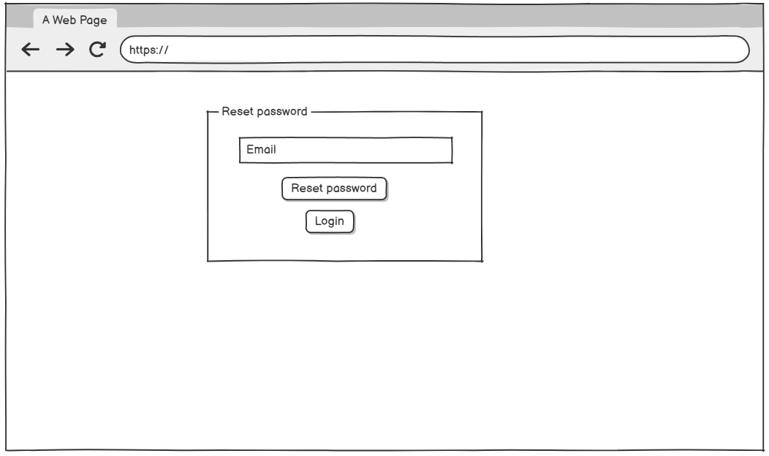

*Figure 17– Password Reset Mock Up*

###### 3.1.3.1 UI Requirement

| No. | Field Name | Field Type | Description |
| --- | --- | --- | --- |
| 1 | Email | Input Field | A field for the user to enter their email. |
| 2 | Reset password | Button | A button that triggers the request reset password process. |
| 3 | Login link | Link | Opens screen to the Login functionality. |

*Table 48– Reset Password UI Requirement Mock Up*

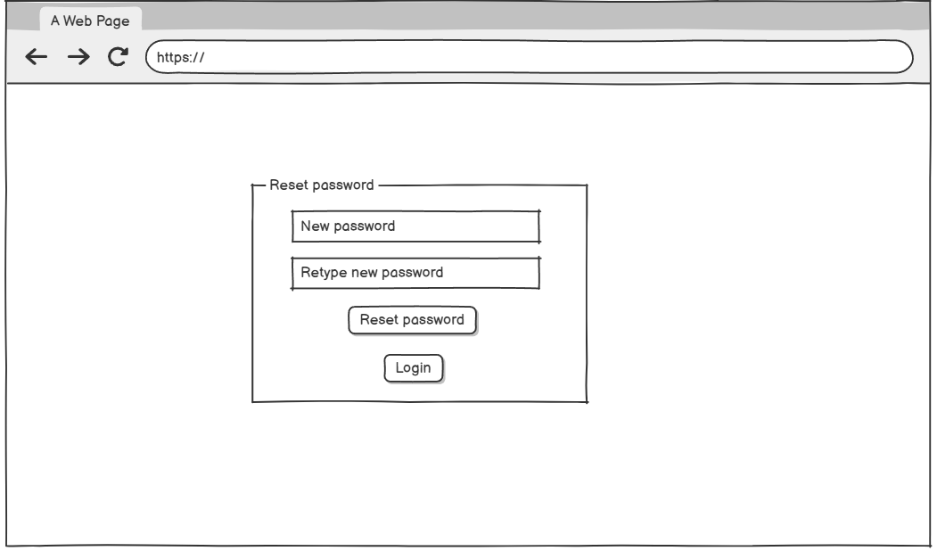

| No. | Field Name | Field Type | Description |
| --- | --- | --- | --- |
| 1 | New Password | Input Field | A field for the user to enter their new password. |
| 2 | Retype New Password | Input Field | A field for the user to retype their new password. |
| 3 | Reset password | Button | A button that triggers the reset password process. |
| 4 | Login link | Link | Opens the screen to the Login functionality. |

*Table 50– Reset Password UI Requirement*

#### 3.1.4 User Profile

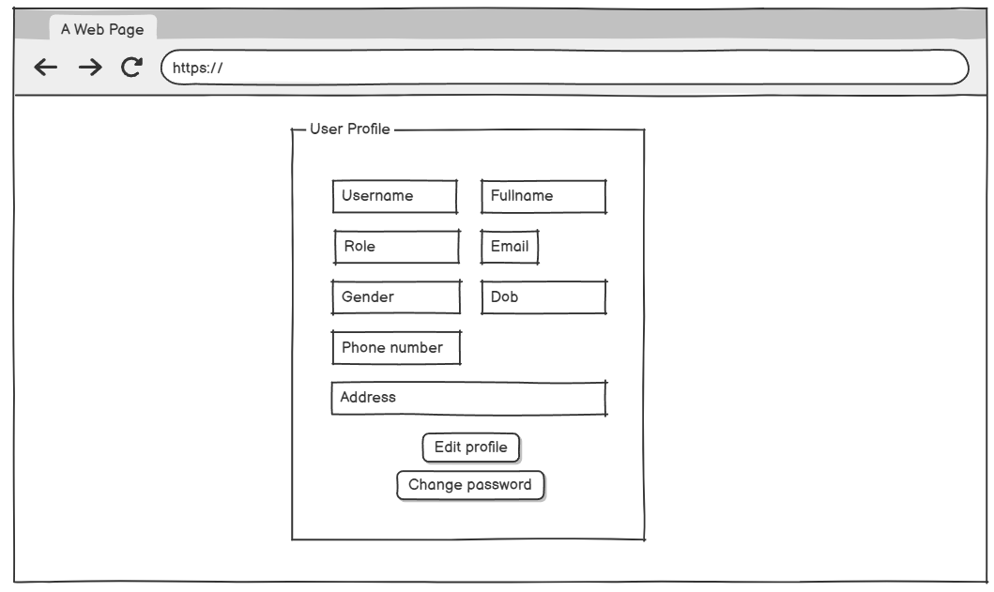

*Figure 18– User Profile Mock Up*

###### 3.1.4.1 UI Requirement

| No. | Field Name | Field Type | Description |
| --- | --- | --- | --- |
| 1 | Username | Textbox | Display the user’s username |
| 2 | Fullname | Textbox | Display the user’s full name |
| 3 | Role | Textbox | Display the user’s role |
| 4 | Email | Textbox | Display the user’s email |
| 5 | Gender | Textbox | Display the user’s gender |
| 6 | Dob | Textbox | Display the user’s date of birth |
| 7 | Phone number | Textbox | Display the user’s phone number |
| 8 | Address | Textbox | Display the user’s address |
| 9 | Reset password | Button | A button that triggers the request reset password process. |
| 10 | Login Link | Link | Open screen to the Change Password functionality. |

*Table 51– User Profile UI Requirement*

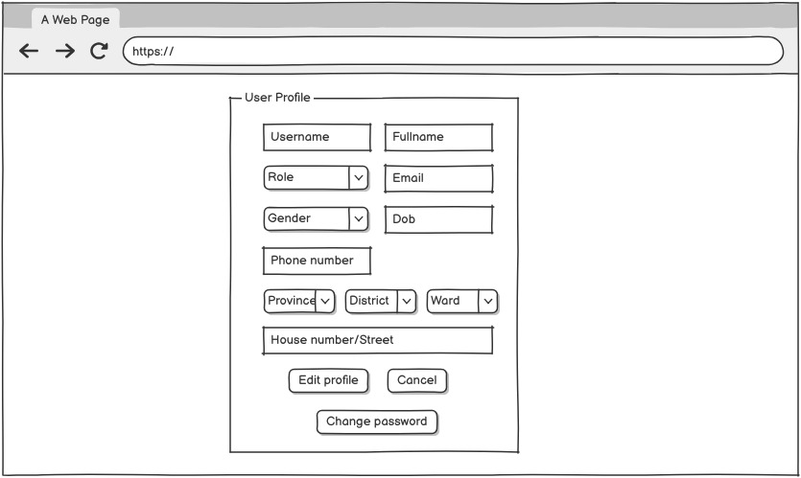

| No. | Field Name | Field Type | Description |
| --- | --- | --- | --- |
| 1 | Username | Textbox | Display the user’s username |
| 2 | Fullname | Textbox | Display the user’s full name |
| 3 | Role | Textbox | Display the user’s role |
| 4 | Email | Textbox | Display the user’s email |
| 5 | Gender | Textbox | Display the user’s gender |
| 6 | Dob | Textbox | Display the user’s date of birth |
| 7 | Phone number | Textbox | Display the user’s phone number |
| 8 | Address | Textbox | Display the user’s address |
| 9 | Reset password | Button | A button that triggers the request reset password process. |
| 10 | Login Link | Link | Opens screen to the Change Password functionality. |

*Table 51– User Profile UI Requirement*

#### 3.2.2 User Management

##### 3.2.2.1 View user List

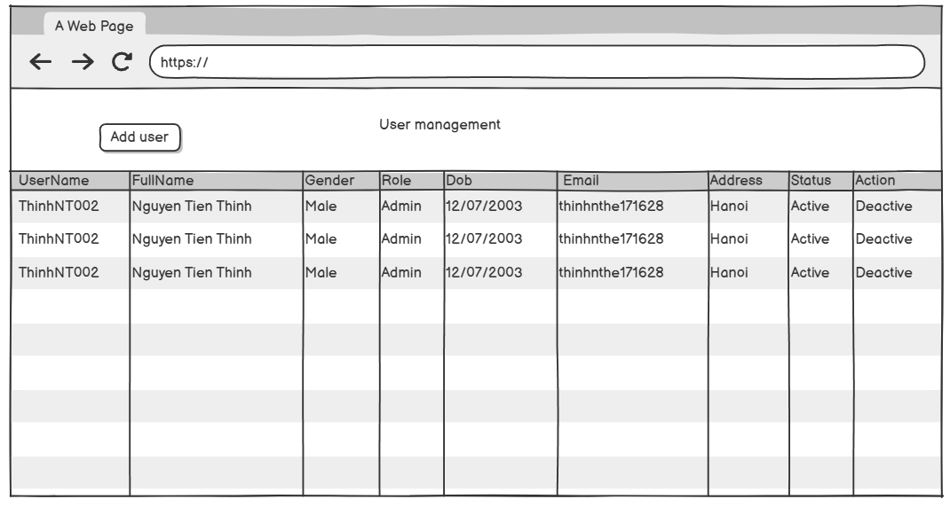

*Figure 19– View user List Mock Up*

###### 3.2.2.1.1 UI Requirement

| **No.** | **Field Name** | **Field Type** | **Description** |
| --- | --- | --- | --- |
| 1 | Title | Text | The screen title: "User management". |
| 2 | Add User Button | Button | Navigates to the Add User form. |
| 3 | Table | Table | Displays a list of users with the following columns: |
| Text | UserName |
| Text | FullName |
| Text | Gender |
| Text | Role |
| Date | Dob |
| Text | Email |
| Text | Address |
| Text | Status |
| Button | Action |

*Table 52– View User List UI Requirement*

##### 3.2.2.2 Add User

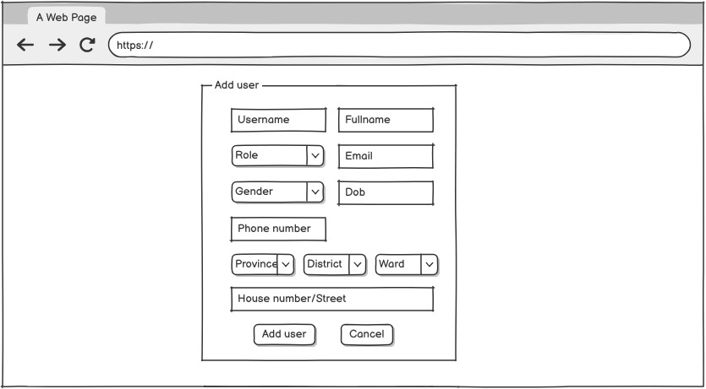

*Figure 20– Add User Mock Up*

###### 3.2.2.2.1 UI Requirement

| **No.** | **Field Name** | **Field Type** | **Description** |
| --- | --- | --- | --- |
| 1 | Username | Input Field | Required field for entering the username of user |
| 2 | Fullname | Input Field | Required field for entering the full name of user |
| 3 | Role | Dropdown | Allows selection of the role of user |
| 4 | Gender | Dropdown | Allows selection of the gender of user |
| 5 | Email | Input Field | Required field for entering the email of user |
| 6 | Dob | Input Field | Required field for entering the date of birth of user |
| 7 | Province | Dropdown | Allows selection of the province of user |
| 8 | District | Dropdown | Allows selection of the district of user |
| 9 | Ward | Dropdown | Allows selection of the ward of user |
| 10 | Add User Button | Button | Provides a button to add a new user. |
| 11 | Cancel Button | Button | Cancels the operation and returns to the previous screen. |

*Table 53– Add User UI Requirement*

### 3.3 Medical Management

##### 3.3.1 Medical Record List

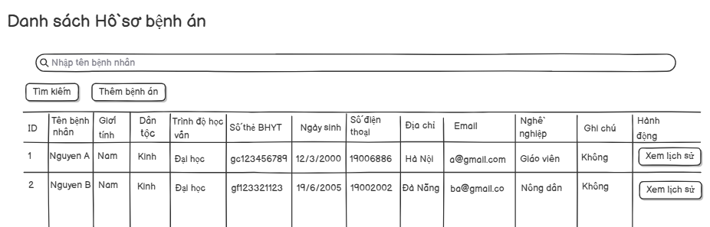

*Figure 21– Medical Record List Mock Up*

###### 3.3.1.1 UI Requirement

| **No.** | **Field Name** | **Field Type** | **Description** |
| --- | --- | --- | --- |
| 1 | Title | Text | The screen title: "Danh sách hồ sơ bệnh án". |
| 2 | Search Bar | Input Field | Input field for searching patients by name. |
| 3 | Search Button | Button | "Search" button to perform the search based on the entered patient name. |
| 4 | Add Medical Record Button | Button | "Add Medical Record" button to navigate to the page for creating a new record. |
| 5 | Medical Record Table | Table | Displays the list of medical records with columns: ID, Patient Name, Gender, EthnicGroup, Education Level, Health Insurance Number, Date of Birth, Phone Number, Address, Email, Occupation, Notes, and Actions. |
| 6 | View History | Button | "View History" button under the Action column to view the patient’s medical history. |
| 7 | Back Button | Button | "Back" button to return to the previous screen. |

*Table 54– Medical Record List UI Requirement*

##### 3.3.2 Personal Medical Record History List

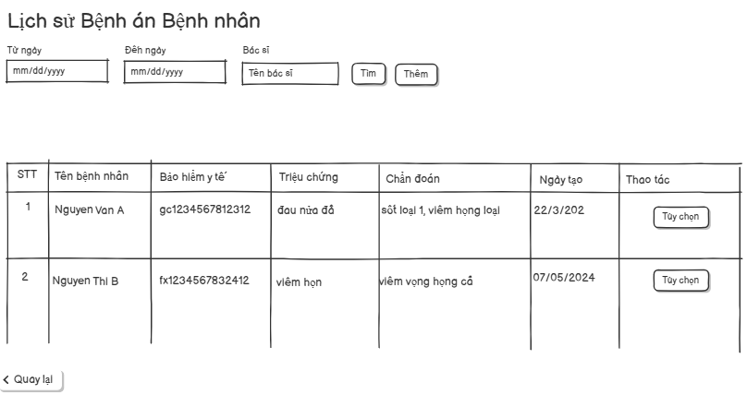

*Figure 22– Personal Medical Record History List Mock Up*

###### 3.3.2.1 UI Requirement

| **No.** | **Field Name** | **Field Type** | **Description** |
| --- | --- | --- | --- |
| 1 | Title | Text | The screen title: "Lịch sử Bệnh án Bệnh nhân". |
| 2 | From Date | Input Field | Date picker to select the starting date for filtering. |
| 3 | From Date | Input Field | Date picker to select the ending date for filtering. |
| 4 | Doctor Name | Input Field | Input field to filter by doctor name. |
| 5 | Search Button | Button | Executes the search based on entered filters. |
| 6 | Add History Button | Button | Adds a new medical history record. |
| 7 | Table | Table | Displays the medical history list with columns: No., Patient Name, Insurance Code, Symptoms, Diagnosis, Creation Date, and Actions. |
| 8 | Detail Button | Button | Opens detailed view for the selected medical history record. |
| 9 | Prescribe Medication Button | Button | Opens screen to prescribe medication for the selected record. |
| 10 | External Prescription Button | Button | Opens screen to create/view prescriptions outside the main system. |
| 11 | Medication Details Button | Button | Views the details of the internal prescription. |
| 12 | External Medication Details Button | Button | Views the details of the external prescription. |
| 13 | Medical Record Detail Section | Text Section | Displays the details of the selected medical history record or shows a message prompting selection. |
| 14 | Back Button | Button | Provides a button to navigates back to the previous screen. |

*Table 55– Personal Medical Record History List UI Requirement*

##### 3.3.3 Medical Record History List

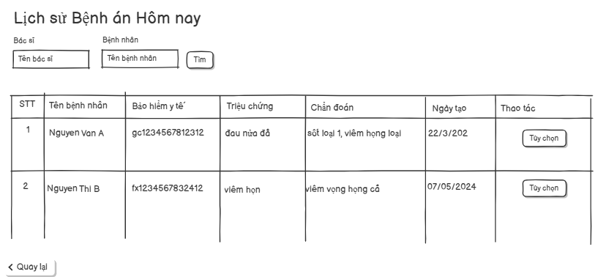

*Figure 23– Medical Record History List Mock Up*

###### 3.3.3.1 UI Requirement

| **No.** | **Field Name** | **Field Type** | **Description** |
| --- | --- | --- | --- |
| 1 | Title | Text | The screen title: "Lịch sử Bệnh án". |
| 2 | From Date | Input Field | Date picker to select the starting date for filtering. |
| 3 | From Date | Input Field | Date picker to select the ending date for filtering. |
| 4 | Doctor Name | Input Field | Input field to filter by doctor name. |
| 5 | Patient Name | Input Field | Input field to filter by patient name. |
| 6 | Search Button | Button | Executes the search based on entered filters. |
| 7 | Table | Table | Displays the medical history list with columns: No., Patient Name, Insurance Code, Symptoms, Diagnosis, Creation Date, and Actions. |
| 8 | Detail Button | Button | Opens detailed view for the selected medical history record. |
| 9 | Medical Record Detail Section | Text Section | Displays the details of the selected medical history record or shows a message prompting selection. |
| 10 | Back Button | Button | Provides a button to navigate back to the previous screen. |

*Table 56– Medical Record History List UI Requirement*

##### 3.3.4 Add Medical Record History

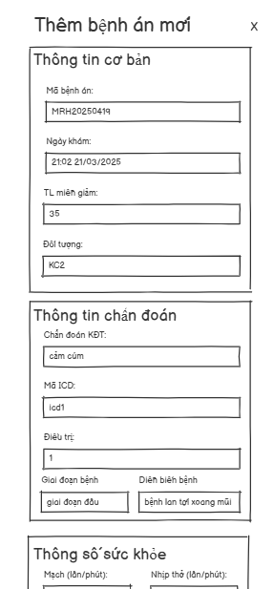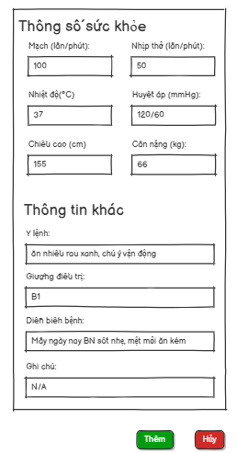

*Figure 24– Add Medical Record History Mock Up*

###### 3.3.4.1 UI Requirement

| **No.** | **Field Name** | **Field Type** | **Description** |
| --- | --- | --- | --- |
| 1 | "Medical Record ID" Label | Label | Label for the Medical Record ID input field |
| 2 | Medical Record ID | TextBox | Input for the medical record identification number |
| 3 | "Examination Date" Label | Label | Label for the Examination Date input field |
| 4 | Examination Date | TextBox (datetime) | Input for the date and time of examination |
| 5 | "Discount Rate" Label | Label | Label for the Discount Rate input field |
| 6 | Discount Rate | TextBox (number) | Input for discount rate percentage |
| 7 | "Patient Type" Label | Label | Label for the Patient Type input field |
| 8 | Patient Type | TextBox | Input for patient category (e.g., insurance group) |
| 9 | "Preliminary Diagnosis" Label | Label | Label for Preliminary Diagnosis input |
| 10 | Preliminary Diagnosis | TextBox | Input for the initial diagnosis description |
| 11 | "ICD Code" Label | Label | Label for ICD Code input field |
| 12 | ICD Code | TextBox | Input for the ICD classification code |
| 13 | "Treatment" Label | Label | Label for Treatment input field |
| 14 | Treatment | TextBox | Input for treatment method |
| 15 | "Disease Stage" Label | Label | Label for Disease Stage input field |
| 16 | Disease Stage | TextBox | Input for the disease stage |
| 17 | "Disease Progression" Label | Label | Label for Disease Progression input field |
| 18 | Disease Progression | TextBox | Input for disease progression description |
| 19 | "Pulse" Label | Label | Label for Pulse input field |
| 20 | Pulse (beats/min) | TextBox (number) | Input for pulse rate |
| 21 | "Respiration Rate" Label | Label | Label for Respiration Rate input field |
| 22 | Respiration Rate (breaths/min) | TextBox (number) | Input for respiration rate |
| 23 | "Body Temperature" Label | Label | Label for Body Temperature input field |
| 24 | Body Temperature (°C) | TextBox (number) | Input for body temperature |
| 25 | "Blood Pressure" Label | Label | Label for Blood Pressure input field |
| 26 | Blood Pressure (mmHg) | TextBox | Input for blood pressure reading |
| 27 | "Height" Label | Label | Label for Height input field |
| 28 | Height (cm) | TextBox (number) | Input for patient height |
| 29 | "Weight" Label | Label | Label for Weight input field |
| 30 | Weight (kg) | TextBox (number) | Input for patient weight |
| 31 | "Doctor's Orders" Label | Label | Label for Doctor's Orders input field |
| 32 | Doctor's Orders | TextArea | Input for doctor's instructions |
| 33 | "Treatment Bed" Label | Label | Label for Treatment Bed input field |
| 34 | Treatment Bed | TextBox | Input for assigned treatment bed |
| 35 | "Hospitalization Progress" Label | Label | Label for Hospitalization Progress input field |
| 36 | Hospitalization Progress | TextArea | Input for patient's progress during hospitalization |
| 37 | "Notes" Label | Label | Label for Notes input field |
| 38 | Notes | TextArea | Input for additional notes |
| 39 | "Add" Button | Button | Button to save the new medical record |
| 40 | "Cancel" Button | Button | Button to cancel the operation |

*Table 57– Add Medical Record History UI Requirement*

##### 3.3.5 Edit Medical Record History

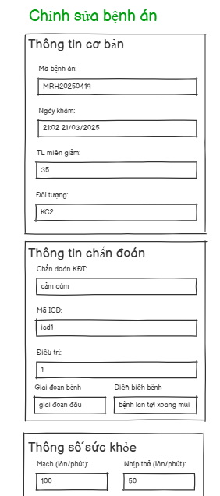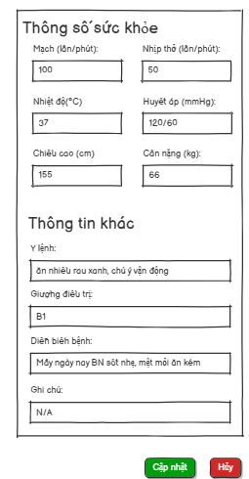

*Figure 25– Edit Medical Record History Mock Up*

###### 3.3.5.1 UI Requirement

| **No.** | **Field Name** | **Field Type** | **Description** |
| --- | --- | --- | --- |
| 1 | "Medical Record ID" Label | Label | Label for input of medical record code |
| 2 | Medical Record ID | TextBox | Field to input/edit the unique medical record ID |
| 3 | "Examination Date" Label | Label | Label for examination date and time |
| 4 | Examination Date | TextBox (datetime) | Field to input/edit date and time of examination |
| 5 | "Discount Rate" Label | Label | Label for insurance discount rate input |
| 6 | Discount Rate (%) | TextBox (number) | Input field for discount rate |
| 7 | "Patient Type" Label | Label | Label for patient group/category |
| 8 | Patient Type | TextBox | Input for patient category (e.g. KC1, KC2, etc.) |
| 9 | "Preliminary Diagnosis" Label | Label | Label for preliminary diagnosis |
| 10 | Preliminary Diagnosis | TextBox | Input field for diagnosis result |
| 11 | "ICD Code" Label | Label | Label for ICD classification code |
| 12 | ICD Code | TextBox | Input field for ICD disease code |
| 13 | "Treatment" Label | Label | Label for treatment plan |
| 14 | Treatment | TextBox | Field to input treatment details |
| 15 | "Disease Stage" Label | Label | Label for current disease stage |
| 16 | Disease Stage | TextBox | Input field for disease phase |
| 17 | "Progression" Label | Label | Label for disease progression |
| 18 | Progression | TextBox | Field to input notes on disease spread/progress |
| 19 | "Pulse" Label | Label | Label for pulse rate |
| 20 | Pulse (beats/min) | TextBox (number) | Field for number of heartbeats per minute |
| 21 | "Respiration Rate" Label | Label | Label for breathing rate |
| 22 | Respiration Rate (breaths/min) | TextBox (number) | Field for number of breaths per minute |
| 23 | "Temperature" Label | Label | Label for body temperature |
| 24 | Temperature (°C) | TextBox (number) | Field for body temperature |
| 25 | "Blood Pressure" Label | Label | Label for systolic/diastolic input |
| 26 | Blood Pressure (mmHg) | TextBox | Field for blood pressure reading |
| 27 | "Height" Label | Label | Label for height input |
| 28 | Height (cm) | TextBox (number) | Field for height in centimeters |
| 29 | "Weight" Label | Label | Label for weight input |
| 30 | Weight (kg) | TextBox (number) | Field for weight in kilograms |
| 31 | "Doctor’s Orders" Label | Label | Label for advice/instructions from doctor |
| 32 | Doctor’s Orders | TextArea | Text area for doctor's recommendations |
| 33 | "Treatment Bed" Label | Label | Label for treatment bed assignment |
| 34 | Treatment Bed | TextBox | Input field for bed number or code |
| 35 | "Hospital Progress" Label | Label | Label for patient update during hospitalization |
| 36 | Hospital Progress | TextArea | Text area for daily progress or symptoms |
| 37 | "Notes" Label | Label | Label for any additional notes |
| 38 | Notes | TextArea | Text area for extra comments |
| 39 | "Update" Button | Button (green) | Action button to confirm editing |
| 40 | "Cancel" Button | Button (red) | Action button to discard edits |

*Table 58– Edit Medical Record History UI Requirement*

##### 3.3.6 Medical Record History Detail

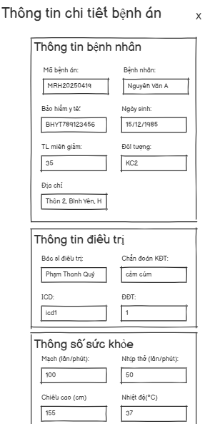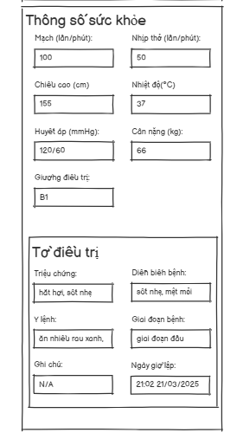

*Figure 26– Medical Record History Detail Mock Up*

###### 3.3.6.1 UI Requirement

| **No.** | **Field Name** | **Field Type** | **Description** |
| --- | --- | --- | --- |
| 1 | "Medical Record ID" | Label | Label for Medical Record ID |
| 2 | Medical Record ID | TextBox (readonly) | Medical record identification number |
| 3 | "Patient Name" | Label | Label for patient full name |
| 4 | Patient Name | TextBox (readonly) | Patient's name |
| 5 | "Health Insurance" | Label | Label for health insurance number |
| 6 | Health Insurance | TextBox (readonly) | Health insurance code |
| 7 | "Date of Birth" | Label | Label for date of birth |
| 8 | Date of Birth | TextBox (readonly) | Patient's birth date |
| 9 | "Discount Rate" | Label | Label for discount rate |
| 10 | Discount Rate | TextBox (readonly) | Discount percentage |
| 11 | "Patient Type" | Label | Label for patient category |
| 12 | Patient Type | TextBox (readonly) | Type of patient |
| 13 | "Address" | Label | Label for address |
| 14 | Address | TextBox (readonly) | Patient's address |
| 15 | "Doctor In Charge" | Label | Label for treating doctor |
| 16 | Doctor In Charge | TextBox (readonly) | Name of doctor |
| 17 | "Preliminary Diagnosis" | Label | Label for preliminary diagnosis |
| 18 | Preliminary Diagnosis | TextBox (readonly) | Initial diagnosis |
| 19 | "ICD Code" | Label | Label for ICD code |
| 20 | ICD Code | TextBox (readonly) | ICD code |
| 21 | "Treatment" | Label | Label for treatment method |
| 22 | Treatment | TextBox (readonly) | Treatment applied |
| 23 | "Pulse" | Label | Label for pulse |
| 24 | Pulse (bpm) | TextBox (readonly) | Pulse in bpm |
| 25 | "Respiratory Rate" | Label | Label for respiratory rate |
| 26 | Respiratory Rate (bpm) | TextBox (readonly) | Breaths per minute |
| 27 | "Height" | Label | Label for height |
| 28 | Height (cm) | TextBox (readonly) | Height in cm |
| 29 | "Body Temperature" | Label | Label for body temperature |
| 30 | Body Temperature (°C) | TextBox (readonly) | Body temperature in Celsius |
| 31 | "Blood Pressure" | Label | Label for blood pressure |
| 32 | Blood Pressure (mmHg) | TextBox (readonly) | Systolic/Diastolic reading |
| 33 | "Weight" | Label | Label for weight |
| 34 | Weight (kg) | TextBox (readonly) | Weight in kilograms |
| 35 | "Treatment Bed" | Label | Label for treatment bed |
| 36 | Treatment Bed | TextBox (readonly) | Name/code of bed |
| 37 | "Symptoms" | Label | Label for symptoms |
| 38 | Symptoms | TextBox (readonly) | Symptoms displayed |
| 39 | "Disease Progression" | Label | Label for disease progression |
| 40 | Disease Progression | TextBox (readonly) | Disease progress |
| 41 | "Doctor's Orders" | Label | Label for doctor's instructions |
| 42 | Doctor's Orders | TextArea (readonly) | Instructions |
| 43 | "Disease Stage" | Label | Label for disease stage |
| 44 | Disease Stage | TextBox (readonly) | Disease stage |
| 45 | "Notes" | Label | Label for notes |
| 46 | Notes | TextArea (readonly) | Additional remarks |
| 47 | "Examination Date" | Label | Label for examination date |
| 48 | Examination Date | TextBox (readonly) | Date and time of examination |

*Table 59– Medical Record History Detail UI Requirement*

### 3.4 MedicineManagement

##### 3.4.1 Medicine List

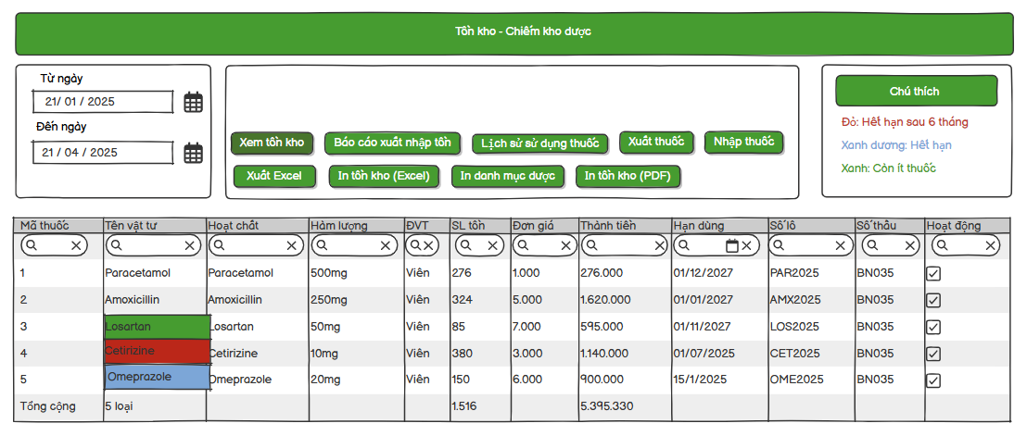

*Figure 27– Medicine List Mock Up*

###### 3.4.1.1 UI Requirement

| **No.** | **Field Name** | **Field Type** | **Description** |
| --- | --- | --- | --- |
| 1 | Title | Text | The screen title: "Tồn kho - Chiếm kho dược". |
| 2 | From Date | Input Field | Date picker to select the starting date for filtering. |
| 3 | To Date | Input Field | Date picker to select the ending date for filtering. |
| 4 | View List Medicine Button | Button | Button to view list medicine information in Inventory |
| 5 | Consume Medicine Report Button | Button | Display list of consume, import, expired, existing medicine in Inventory. |
| 6 | Consumption Medicine History Button | Button | View list of consume medicine history. |
| 7 | Export Medicine Button | Button | Export medicine to use or to discard. |
| 8 | Add Medicine to Inventory Button | Button | Create medicine form to add medicines to inventory from suppliers . |
| 9 | Export excel | Button | Export medicine list filter by date to Excel. |
| 10 | Export PDF | Button | Export medicine list filter by date to PDF. |
| 11 | Annotation Field | Annotation | Displays inventory status: Red (Expired after 6 months), Green (Low stock), Blue(Expired). |
| 12 | Medicine List in Inventory | Table | Table displaying medicine inventory details (e.g., Mã thuốc, Tên vật tư, Hoạt chất, etc.). |
| 13 | Search bar | Input Field | Input field to search for medicines. |
| 14 | Total Field | Text | Displays total summary of medicine name, quantity, total price. |

*Table 60– Medicine List UI Requirement*

##### 3.4.2 Consumption medicine history

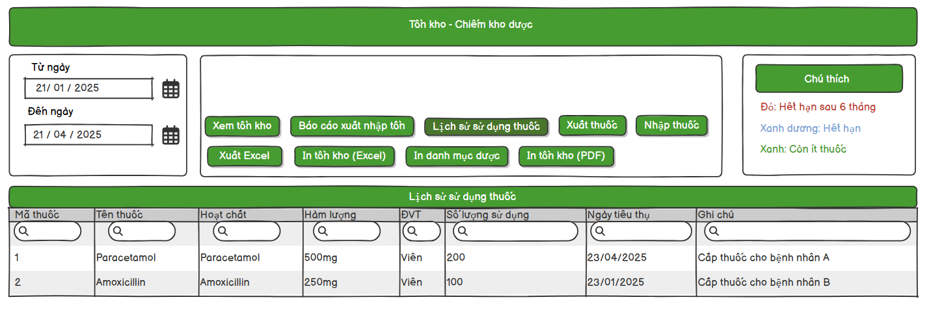

*Figure 28– Consumption medicine history Mock Up*

###### 3.4.2.1 UI Requirement

| **No.** | **Field Name** | **Field Type** | **Description** |
| --- | --- | --- | --- |
| 1 | Title | Text | The screen title: "Tồn kho - Chiếm kho dược". |
| 2 | From Date | Input Field | Date picker to select the starting date for filtering. |
| 3 | To Date | Input Field | Date picker to select the ending date for filtering. |
| 4 | View List Medicine Button | Button | Button to view list medicine information in Inventory |
| 5 | Consume Medicine Report Button | Button | Display list of consume, import, expired, existing medicine in Inventory. |
| 6 | Consumption Medicine History Button | Button | View list of consume medicine history. |
| 7 | Export Medicine Button | Button | Export medicine to use or to discard. |
| 8 | Add Medicine to Inventory Button | Button | Create medicine form to add medicines to inventory from suppliers . |
| 9 | Export excel | Button | Export medicine list filter by date to Excel. |
| 10 | Export PDF | Button | Export medicine list filter by date to PDF. |
| 11 | Annotation Field | Annotation | Displays inventory status: Red (Expired after 6 months), Green (Low stock), Blue(Expired). |
| 12 | ConsumeMedicine Detail Table | Table | Table displaying detail consume medicine quantity and date used. |
| 13 | Search bar | Input Field | Input field to search for medicines. |

*Table 61– Consumption medicine history UI Requirement*

##### 3.4.3 Consume medicine report

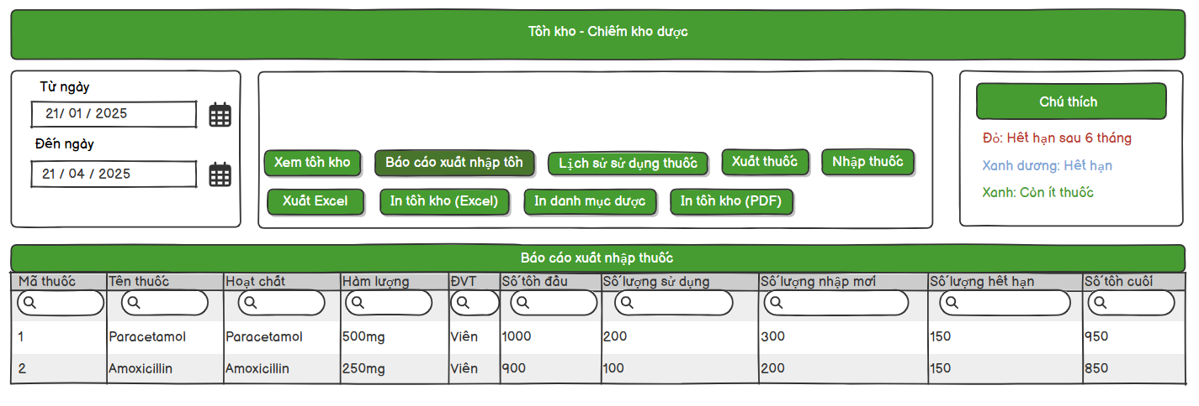

*Figure 29– Consume medicine report Mock Up*

###### 3.4.3.1 UI Requirement

| **No.** | **Field Name** | **Field Type** | **Description** |
| --- | --- | --- | --- |
| 1 | Title | Text | The screen title: "Tồn kho - Chiếm kho dược". |
| 2 | From Date | Input Field | Date picker to select the starting date for filtering. |
| 3 | To Date | Input Field | Date picker to select the ending date for filtering. |
| 4 | View List Medicine Button | Button | Button to view list medicine information in Inventory |
| 5 | Consume Medicine Report Button | Button | Display list of consume, import, expired, existing medicine in Inventory. |
| 6 | Consumption Medicine History Button | Button | View list of consume medicine history. |
| 7 | Export Medicine Button | Button | Export medicine to use or to discard. |
| 8 | Add Medicine to Inventory Button | Button | Create medicine form to add medicines to inventory from suppliers . |
| 9 | Export excel | Button | Export medicine list filter by date to Excel. |
| 10 | Export PDF | Button | Export medicine list filter by date to PDF. |
| 11 | Annotation Field | Annotation | Displays inventory status: Red (Expired after 6 months), Green (Low stock), Blue(Expired). |
| 12 | Consume Medicine List | Table | Table displaying number of medicine that consume, expired, import. |
| 13 | Search bar | Input Field | Input field to search for medicines. |

*Table 62– Consume medicine report UI Requirement*

##### 3.4.4 Search medicine in Inventory

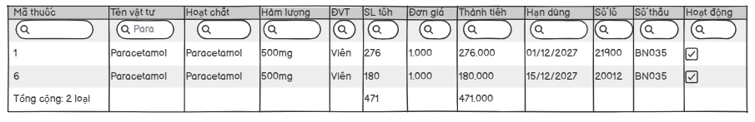

*Figure 30– Search medicine in Inventory Mock Up*

###### 3.4.4.1 UI Requirement

| **No.** | **Field Name** | **Field Type** | **Description** |
| --- | --- | --- | --- |
| 1 | Search Bar | Input Field | Input field to searching medicines. |
| 2 | Total Field | Text | Displays total summary of medicine name, quantity, total price. |

*Table 63– Search medicine in Inventory UI Requirement*

##### 3.4.5 Add medicine to Inventory

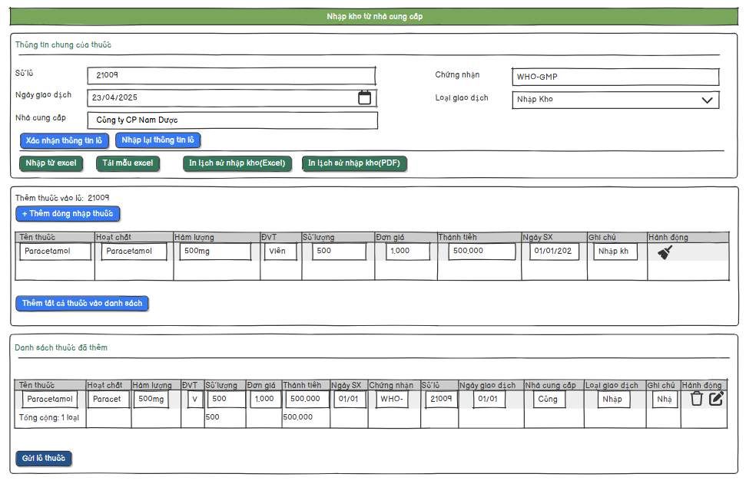

*Figure 31– Add medicine to Inventory Mock Up*

###### 3.4.5.1 UI Requirement

| **No.** | **Field Name** | **Field Type** | **Description** |
| --- | --- | --- | --- |
| 1 | Title Screen | Title Field | The screen title: "Nhập kho từ nhà cung cấp". |
| 2 | Title Form | Title Field | The screen title: "Thông tin chung của thuốc". |
| 3 | Batch form to import | Form | Display form of batch medicine to import. |
| 4 | Batch Number | Label | Label for batch number input. |
| 5 | Batch number input field | Input field | Input Batch number |
| 6 | Certificate number | Label | Label for certificate number input. |
| 7 | Certificate number input field | Input field | Input Batch number |
| 8 | Transaction Date | Label | Label for transaction date input. |
| 9 | Transaction Date Input field | Date | Input Batch number |
| 10 | Transaction Type | Label | Label for transaction type dropdown. |
| 11 | Transaction Type input field | Drop Down | Input Batch number |
| 12 | Supplier | Label | Label for supplier input. |
| 13 | Supplier search bar | Input field | Input Batch number |
| 14 | Confirm batch button | Button | Confirm the batch info and proceed to add medicines. |
| 15 | Re-input batch button | Button | Clear or re-enter batch information. |
| 16 | Import medicine from excel button | Button | Upload medicine batch list from Excel file. |
| 17 | Download excel form button | Button | Download template Excel file for medicine import. |
| 18 | Export imported medicine history to excel button | Button | Export medicine import history to Excel file. |
| 19 | Export imported medicine history to PDF button | Button | Export medicine import history to PDF file. |
| 20 | Add medicine to batch form | Form | Form to add medicine details to the current batch. |
| 21 | Add row button | Button | Add a new row for medicine entry. |
| 22 | Medicine information table | Table | Display list of medicines added in current session. |
| 23 | Add medicine to list button | Button | Add current medicine input to the list. |
| 24 | Clear row button | Button | Clear input in the current row. |
| 25 | List medicine has added form | Form | Form displaying list of added medicines. |
| 26 | Send batch button | Button | Submit the full batch for processing/import. |

*Table 64– Add medicine to Inventory UI Requirement*

##### 3.4.6 Get all added medicine history

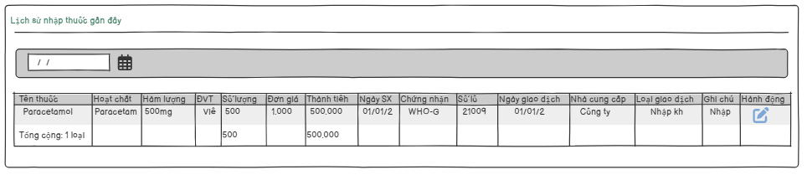

*Figure 32– Get all added medicine history Mock Up*

###### 3.4.6.1 UI Requirement

| **No.** | **Field Name** | **Field Type** | **Description** |
| --- | --- | --- | --- |
| 1 | Title medicine history form | Title | Title of the form displaying medicine import history. |
| 2 | Date Filter | Input Field | Input field to filter medicine history by date (e.g., date range picker). |
| 3 | History medicine added Table | Table | Table displaying list of medicines added in previous import batches. |
| 4 | Edit button | Button | Edit details of a specific medicine entry (available only within 24h). |

*Table 65– Get all added medicine history UI Requirement*

##### 3.4.7 Edit recent medicine added

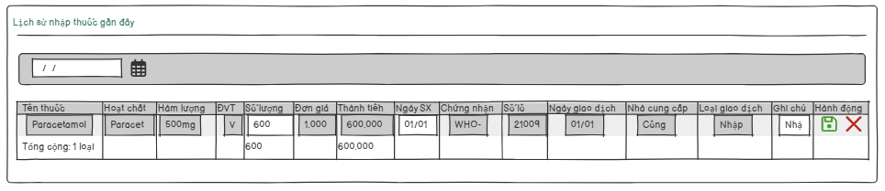

*Figure 33– Edit recent medicine added Mock Up*

###### 3.4.7.1 UI Requirement

| **No.** | **Field Name** | **Field Type** | **Description** |
| --- | --- | --- | --- |
| 1 | Title medicine history form | Title | Title of the form displaying medicine import history. |
| 2 | Date Filter | Input Field | Input field to filter medicine history by date (e.g., date range picker). |
| 3 | History medicine added Table | Table | Table displaying list of medicines added in previous import batches. |
| 4 | Edit button | Button | Edit details of a specific medicine entry (available only within 24h). |
| 5 | Save Button | Button | Save changes made to a medicine entry. |
| 6 | Cancel Button | Button | Cancel editing and revert to previous values. |

*Table 66– Get all added medicine history UI Requirement*

##### 3.4.8 Search medicine by name

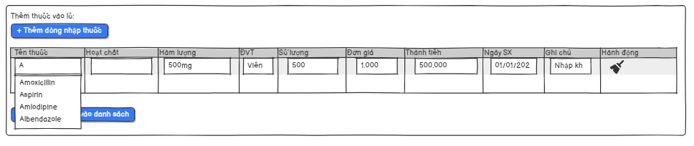

*Figure 34– Search medicine by name Mock Up*

###### 3.4.8.1 UI Requirement

| **No.** | **Field Name** | **Field Type** | **Description** |
| --- | --- | --- | --- |
| 1 | Add medicine to batch form | Form | Form to add medicine details to the current batch. |
| 2 | Add row button | Button | Add a new row for medicine entry. |
| 3 | Medicine information table | Table | Display list of medicines added in current session. |
| 4 | Add medicine to list button | Button | Add current medicine input to the list. |
| 5 | Search medicine field | Input Field | Input name of medicine and a list of medicine match keyword appear |

*Table 67– Search medicine by name UI Requirement*

### 

### 

### 

### 

### 

### 

### 

### 3.5 PrescriptionManagement

##### 3.5.1 Prescription List

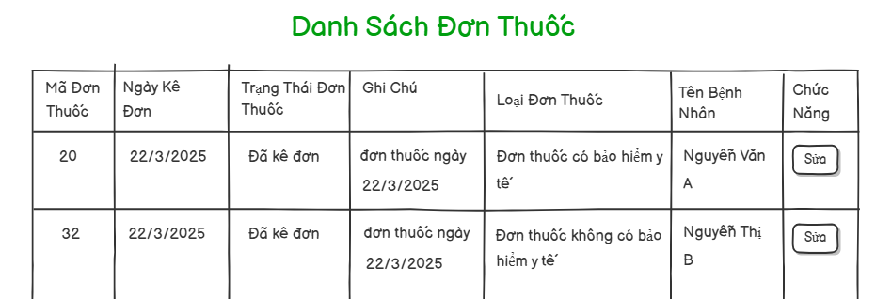

*Figure 35– Prescription List Mock Up*

###### 3.5.1.1 UI Requirement

| **No.** | **Field Name** | **Field Type** | **Description** |
| --- | --- | --- | --- |
| 1 | Title medicine prescription | Title | The main heading displayed at the top of the medicine prescription page. |
| 2 | Medicine Prescription table | Table | A table listing all prescribed medicines with their details. |
| 3 | Edit Medicine Prescription button | Button | A button to edit the details of the medicine prescription. |

*Table 68– Prescription List UI Requirement*

##### 3.5.2 External Prescription List

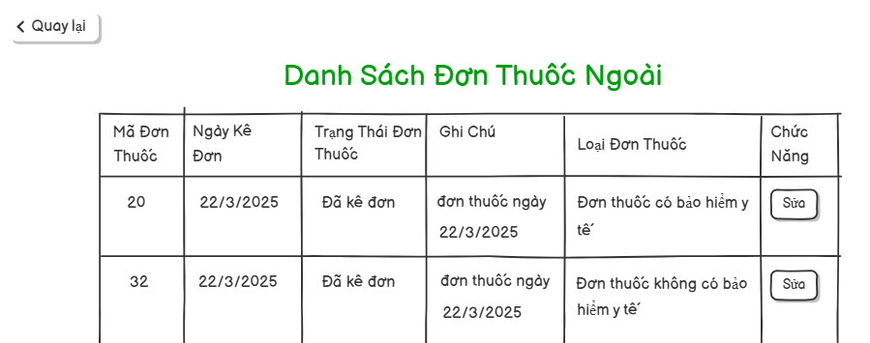

*Figure 36– External Prescription List Mock Up*

###### 3.5.2.1 UI Requirement

| **No.** | **Field Name** | **Field Type** | **Description** |
| --- | --- | --- | --- |
| 1 | Title External medicine prescription | Title | The main heading displayed at the top of the external medicine prescription page. |
| 2 | External Medicine Prescription table | Table | A table listing all externally prescribed medicines with their relevant details. |
| 3 | Edit External Medicine Prescription button | Button | A button to edit the details of the external medicine prescription. |
| 4 | Back button | Button | A button to return to the previous page or external prescription listing. |

*Table 69– External Prescription List UI Requirement*

##### 3.5.3 Use Medical Supply List

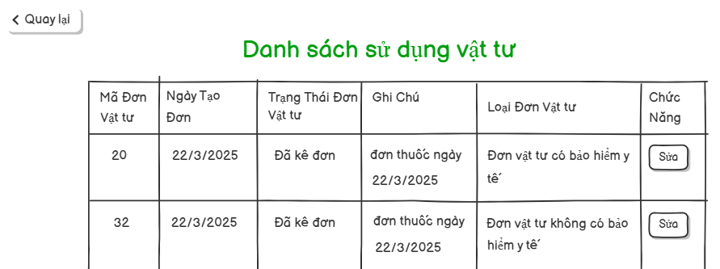

*Figure 37– Use Medical Supply List Mock Up*

###### 3.5.3.1 UI Requirement

| **No.** | **Field Name** | **Field Type** | **Description** |
| --- | --- | --- | --- |
| 1 | Title medical  Supply usage | Title | The main heading displayed at the top of the medical supply usage page. |
| 2 | Medical Supply Usage table | Table | A table listing all used medical supplies with their relevant details. |
| 3 | Edit Medical Supply Usage button | Button | A button to edit the details of the medical supply usage record. |
| 4 | Back button | Button | A button to return to the previous page or medical supply usage listing. |

*Table 70– Use Medical Supply List UI Requirement*

##### 3.5.4 Add Prescription

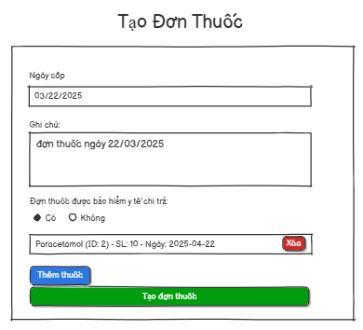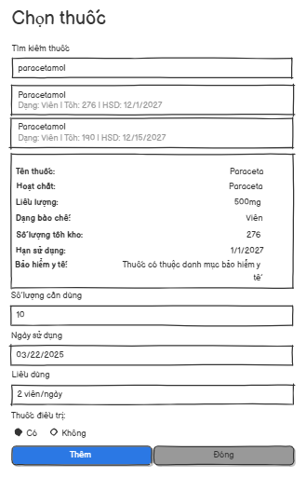

*Figure 38– Add Prescription Mock Up*

###### 3.5.4.1 UI Requirement

| **No.** | **Field Name** | **Field Type** | **Description** |
| --- | --- | --- | --- |
| 1 | Create Prescription Title | Title | The screen title: "Tạo Đơn Thuốc" (Create Prescription). |
| 2 | Issue Date Label | Label | Label for the issue date field. |
| 3 | Issue Date Input Field | Input Field | Input field to enter the prescription issue date (format: mm/dd/yyyy). |
| 4 | Note Label | Label | Label for the note section. |
| 5 | Note Textarea | Textarea | Textarea for entering prescription notes. |
| 6 | Insurance Coverage Label | Label | Label: “Prescription covered by health insurance”. |
| 7 | Insurance Yes Radio Button | Radio Button | Option to mark the prescription as covered by insurance. |
| 8 | Insurance No Radio Button | Radio Button | Option to mark the prescription as not covered by insurance. |
| 9 | Medicine Item Display | List Item | Display of added medicine: name, ID, quantity, date. |
| 10 | Delete Medicine Button | Button | Red "Delete" button to remove a medicine from the list. |
| 11 | Add Medicine Button | Button | Blue button labeled "Add Medicine" to add a new medicine to the list. |
| 12 | Submit Prescription Button | Button | Green button labeled "Create Prescription" to submit the prescription. |
| 13 | Select Medicine Title | Title | Title of the screen: "Chọn thuốc" (Select Medicine). |
| 14 | Medicine Search Input | Input Field | Input field to search for medicine by name. |
| 15 | Search Result Item | List Item | Each row showing search results: medicine name, form, quantity, expiry. |
| 16 | Medicine Details Box | Information Box | Shows selected medicine's details (name, ingredient, dosage, etc.). |
| 17 | Quantity Needed Label | Label | Label for required quantity input. |
| 18 | Quantity Needed Input | Input Field | Field to input the number of units needed. |
| 19 | Usage Date Label | Label | Label for the usage start date. |
| 20 | Usage Date Input | Input Field | Field to input the date when medicine use starts. |
| 21 | Dosage Label | Label | Label for the dosage (e.g., frequency of use). |
| 22 | Dosage Input | Input Field | Field to input dosage (e.g., “2 viên/ngày” = 2 tablets/day). |
| 23 | Treatment Medicine Label | Label | Label asking whether this is a treatment medicine. |
| 24 | Treatment Medicine Yes Option | Radio Button | Radio button to mark as a treatment medicine. |
| 25 | Treatment Medicine No Option | Radio Button | Radio button to mark as not a treatment medicine. |
| 26 | Add Medicine Button | Button | Blue button labeled “Thêm” (Add) to confirm selection. |
| 27 | Close Button | Button | Gray button labeled “Đóng” (Close) to exit without adding. |

*Table 71– Add Prescription UI Requirement*

##### 3.5.5 Edit Prescription

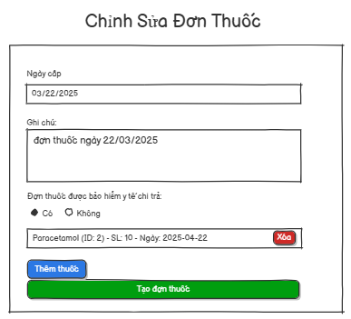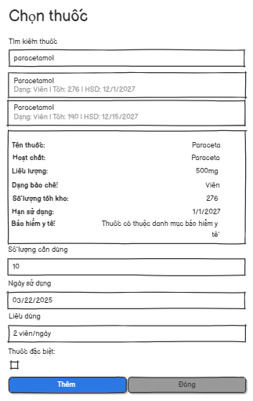

*Figure 39– Edit Prescription Mock Up*

###### 3.5.5.1 UI Requirement

| **No.** | **Field Name** | **Field Type** | **Description** |
| --- | --- | --- | --- |
| 1 | Edit Prescription Title | Title | Screen title: "Chỉnh Sửa Đơn Thuốc" (Edit Prescription). |
| 2 | Issue Date Label | Label | Label for the issue date input. |
| 3 | Issue Date Input Field | Input Field | Input field for prescription issue date. |
| 4 | Note Label | Label | Label for the notes section. |
| 5 | Note Textarea | Textarea | Textarea for notes regarding the prescription. |
| 6 | Insurance Coverage Label | Label | Label: “Prescription covered by health insurance”. |
| 7 | Insurance Yes Radio Button | Radio Button | Option for “Yes” – covered by health insurance. |
| 8 | Insurance No Radio Button | Radio Button | Option for “No” – not covered. |
| 9 | Added Medicine Item | List Item | Display of added medicine: name, ID, quantity, date, with delete button. |
| 10 | Delete Medicine Button | Button | Red "Xóa" (Delete) button to remove a medicine. |
| 11 | Add Medicine Button | Button | Blue "Thêm thuốc" (Add medicine) button to open the selection interface. |
| 12 | Submit Edited Prescription Button | Button | Green "Tạo đơn thuốc" (Create prescription) button to save changes. |
| 13 | Select Medicine Title | Title | Title: "Chọn thuốc" (Select Medicine). |
| 14 | Medicine Search Input | Input Field | Search bar to find medicine by name. |
| 15 | Search Result Item | List Item | Search result row showing name, form, quantity, expiry. |
| 16 | Medicine Details Display Box | Info Box | Displays selected medicine details: ingredient, dosage, form, etc. |
| 17 | Quantity Needed Label | Label | Label for required quantity. |
| 18 | Quantity Needed Input | Input Field | Field to input how much is needed. |
| 19 | Usage Date Label | Label | Label for when medicine will be used. |
| 20 | Usage Date Input Field | Input Field | Field to input usage date. |
| 21 | Dosage Label | Label | Label for dosage instructions. |
| 22 | Dosage Input Field | Input Field | Field to enter dosage info (e.g., 2 tablets/day). |
| 23 | Special Treatment Label | Label | Label asking if the medicine is for special treatment. |
| 24 | Special Treatment Option | Radio Button | "Có" – Yes for special treatment. |
| 25 | Special Treatment No Option | Radio Button | "Không" – No special treatment. |
| 26 | Add Selected Medicine Button | Button | Blue "Thêm" (Add) button to confirm medicine selection. |
| 27 | Close Selection Button | Button | Gray "Đóng" (Close) button to cancel medicine selection. |

*Table 72– Edit Prescription UI Requirement*

##### 3.5.6 Add Use Medical Supply

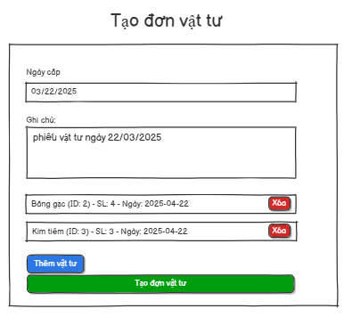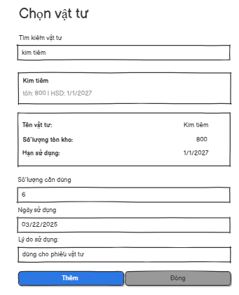

*Figure 40– Add Use Medical Supply Mock Up*

###### 3.5.6.1 UI Requirement

| **No.** | **Field Name** | **Field Type** | **Description** |
| --- | --- | --- | --- |
| 1 | Create Supply Order Title | Title | Screen title: "Tạo đơn vật tư" (Create Medical Supply Order). |
| 2 | Issue Date Label | Label | Label for date of creation. |
| 3 | Issue Date Input Field | Input Field | Input for the creation date of the supply order. |
| 4 | Note Label | Label | Label for the notes section. |
| 5 | Note Textarea | Textarea | Textarea for supply order note. |
| 6 | Added Supply Item Display | List Item | Shows added supplies with name, ID, quantity, usage date, and delete button. |
| 7 | Delete Supply Button | Button | Red "Xóa" (Delete) button for each supply. |
| 8 | Add Supply Button | Button | Blue "Thêm vật tư" (Add Supply) button to open selection popup. |
| 9 | Create Supply Order Button | Button | Green "Tạo đơn vật tư" (Create Supply Order) to submit the form. |
| 10 | Select Supply Title | Title | Screen title: "Chọn vật tư" (Select Medical Supply). |
| 11 | Supply Search Input | Input Field | Input to search for a supply by name. |
| 12 | Search Result Item | List Item | Supply name + stock + expiry shown in search result. |
| 13 | Supply Details Display | Info Box | Box showing selected supply details: name, stock, expiry date. |
| 14 | Quantity Needed Label | Label | Label for required quantity input. |
| 15 | Quantity Needed Input | Input Field | Input for amount of supply needed. |
| 16 | Usage Date Label | Label | Label for date the supply is needed. |
| 17 | Usage Date Input | Input Field | Input field for supply usage date. |
| 18 | Usage Note Label | Label | Label for reason or usage note. |
| 19 | Usage Note Textarea | Textarea | Input for usage note or purpose. |
| 20 | Confirm Add Supply Button | Button | Blue "Thêm" (Add) button to confirm and add supply to list. |
| 21 | Close Selection Button | Button | Grey "Đóng" (Close) button to cancel selection. |

*Table 73– Add Use Medical Supply UI Requirement*

##### 3.5.7 Prescription Detail

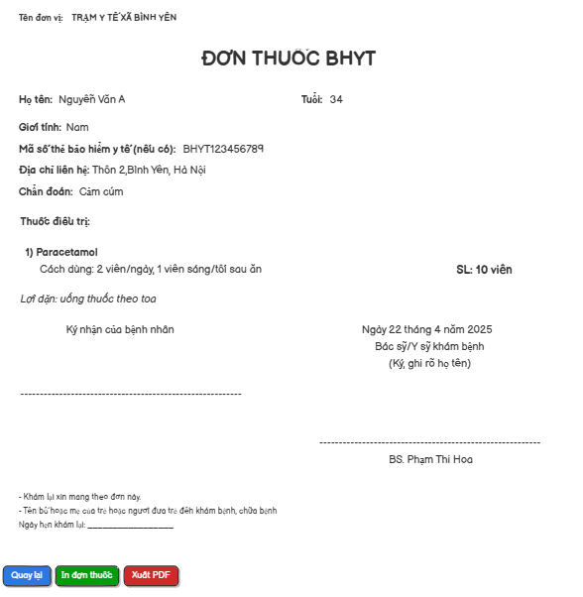

*Figure 41– Prescription Detail Mock Up*

###### 3.5.7.1 UI Requirement

| **No.** | **Field Name** | **Field Type** | **Description** |
| --- | --- | --- | --- |
| 1 | Title (Unit Name) | Label | “Tên đơn vị: TRẠM Y TẾ XÃ BÌNH YÊN” (Health Center/Unit name). |
| 2 | Prescription Title | Title | “ĐƠN THUỐC BHYT” (Health Insurance Prescription). |
| 3 | Patient Name | Text Field | Patient’s full name |
| 4 | Age | Text Field | Patient’s age |
| 5 | Gender | Text Field | Gender |
| 6 | Insurance Code | Text Field | Patient’s health insurance number (if available). |
| 7 | Address | Text Field | Patient’s contact address. |
| 8 | Diagnosis | Text Field | Patient’s diagnosis (e.g., flu, fever). |
| 9 | Treatment Medicine List | Text | Shows a list of prescribed medicine(s) |
| 10 | Dosage Instruction | Text | Usage instructions, e.g., “2 pills/day, 1 morning/1 night”. |
| 11 | Quantity | Text | Number of units prescribed (e.g., 10 pills). |
| 12 | Usage Note | Italic Text | Additional instructions like “Use as prescribed”. |
| 17 | Notice Text | Small Text | Instructions for patients about using the prescription form. |
| 18 | Print Button | Button | Blue “Quay lại” (Back). |
| 19 | Print Prescription Button | Button | Green “In đơn thuốc” (Print Prescription). |
| 20 | Export PDF Button | Button | Red “Xuất PDF” (Export PDF). |

*Table 74– Prescription Detail UI Requirement*

##### 3.5.8 External Prescription Detail

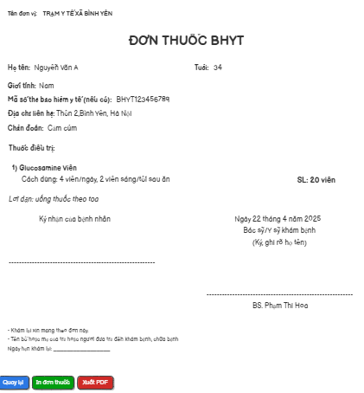

*Figure 42– External Prescription Detail Mock Up*

###### 3.5.8.1 UI Requirement

| **No.** | **Field Name** | **Field Type** | **Description** |
| --- | --- | --- | --- |
| 1 | Title (Unit Name) | Label | “Tên đơn vị: TRẠM Y TẾ XÃ BÌNH YÊN” (Health Center/Unit name). |
| 2 | Prescription Title | Title | “ĐƠN THUỐC” (Health Insurance Prescription). |
| 3 | Patient Name | Text Field | Patient’s full name |
| 4 | Age | Text Field | Patient’s age |
| 5 | Gender | Text Field | Gender |
| 6 | Insurance Code | Text Field | Patient’s health insurance number (if available). |
| 7 | Address | Text Field | Patient’s contact address. |
| 8 | Diagnosis | Text Field | Patient’s diagnosis (e.g., flu, fever). |
| 9 | Treatment Medicine List | Text | Shows a list of prescribed medicine(s) |
| 10 | Dosage Instruction | Text | Usage instructions, e.g., “2 pills/day, 1 morning/1 night”. |
| 11 | Quantity | Text | Number of units prescribed (e.g., 10 pills). |
| 12 | Usage Note | Italic Text | Additional instructions like “Use as prescribed”. |
| 17 | Notice Text | Small Text | Instructions for patients about using the prescription form. |
| 18 | Print Button | Button | Blue “Quay lại” (Back). |
| 19 | Print Prescription Button | Button | Green “In đơn thuốc” (Print Prescription). |
| 20 | Export PDF Button | Button | Red “Xuất PDF” (Export PDF). |

*Table 75– External Prescription Detail UI Requirement*

##### 3.5.9 Use Medical Supply Detail

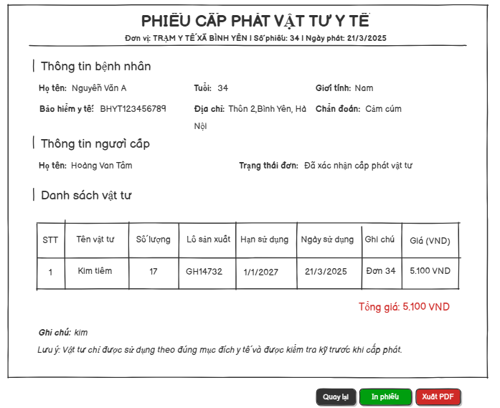

*Figure 43– Use Medical Supply Detail Mock Up*

###### 3.5.9.1 UI Requirement

| **No.** | **Field Name** | **Field Type** | **Description** |
| --- | --- | --- | --- |
| 1 | Title (Unit Name) | Label | “Tên đơn vị: TRẠM Y TẾ XÃ BÌNH YÊN” (Health Center/Unit name). |
| 2 | Prescription Title | Title | “Phiếu cấp phát vật tư y tế” (Health Insurance Prescription). |
| 3 | Patient Name | Text Field | Patient’s full name |
| 4 | Age | Text Field | Patient’s age |
| 5 | Gender | Text Field | Gender |
| 6 | Insurance Code | Text Field | Patient’s health insurance number (if available). |
| 7 | Address | Text Field | Patient’s contact address. |
| 8 | Diagnosis | Text Field | Patient’s diagnosis (e.g., flu, fever). |
| 9 | Treatment Medicine List | Text | Shows a list of prescribed medicine(s) |
| 10 | Quantity | Text | Number of units prescribed (e.g., 10 pills). |
| 11 | Usage Note | Italic Text | Additional instructions like “Use as prescribed”. |
| 12 | Notice Text | Small Text | Instructions for patients about using the prescription form. |
| 13 | Print Button | Button | Blue “Quay lại” (Back). |
| 14 | Print Prescription Button | Button | Green “In đơn thuốc” (Print Prescription). |
| 15 | Export PDF Button | Button | Red “Xuất PDF” (Export PDF). |

*Table 76– Use Medical Supply Detail UI Requirement*

### 3.6 MedicalSupplyManagement

##### 3.6.1 View medical supplies in Inventory

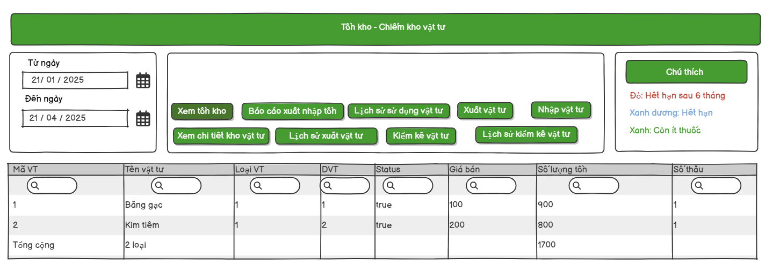

*Figure 44– View medical supplies in Inventory Mock Up*

###### 3.6.1.1 UI Requirement

| **No.** | **Field Name** | **Field Type** | **Description** |
| --- | --- | --- | --- |
| 1 | Title | Text | The screen title: "Tồn kho - Chiếm kho vật tư". |
| 2 | From Date | Input Field | Date picker to select the starting date for filtering. |
| 3 | To Date | Input Field | Date picker to select the ending date for filtering. |
| 4 | View List Medical Supply Button | Button | Button to view list medicine information in Inventory |
| 5 | Consume Medical Supply Report Button | Button | Display list of consume, import, expired, existing medicine in Inventory. |
| 6 | Consumption Medical Supply History Button | Button | View list of consume Medical Supply history. |
| 7 | Export Medical Supply Button | Button | Export Medical Supply to use or to discard. |
| 8 | Add Medical Supply to Inventory Button | Button | Create a Medical Supply form to add Medical Supplies to inventory from suppliers . |
| 9 | Export excel | Button | Export medicine list filter by date to Excel. |
| 10 | Export PDF | Button | Export medicine list filter by date to PDF. |
| 11 | Annotation Field | Annotation | Displays inventory status: Red (Expired after 6 months), Green (Low stock), Blue(Expired). |
| 12 | Medical Supply List in Inventory | Table | Table displaying medicine inventory details (e.g., Mã vật tư, Tên vật tư, etc.). |
| 13 | Search bar | Input Field | Input field to search for Medical Supply . |
| 14 | Total Field | Text | Displays total summary of Medical Supply name, quantity, total price. |

*Table 77– View medical supplies in Inventory UI Requirement*

##### 3.6.2 View medical supplies consumption report

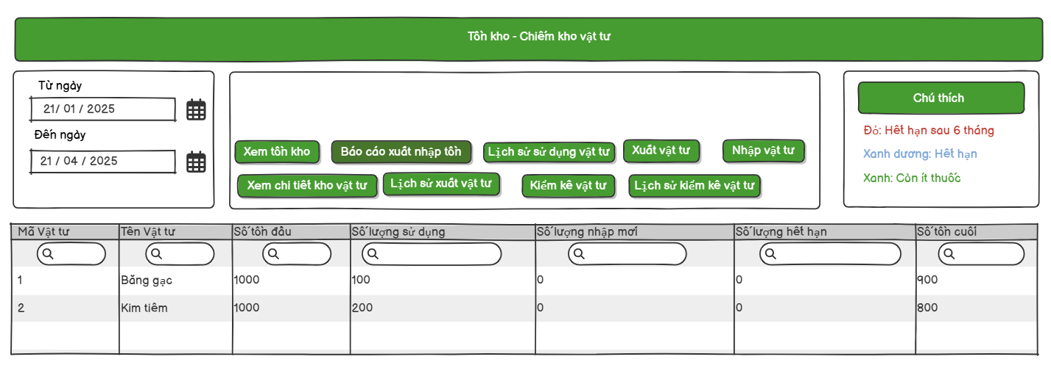

*Figure 45– View medical supplies consumption report Mock Up*

###### 3.6.2.1 UI Requirement

| **No.** | **Field Name** | **Field Type** | **Description** |
| --- | --- | --- | --- |
| 1 | Title | Text | The screen title: "Tồn kho - Chiếm kho vật tư". |
| 2 | From Date | Input Field | Date picker to select the starting date for filtering. |
| 3 | To Date | Input Field | Date picker to select the ending date for filtering. |
| 4 | View List Medical Supply Button | Button | Button to view list Medical Supply information in Inventory |
| 5 | Consume Medical Supply Report Button | Button | Display list of consume, import, expired, existing Medical Supply in Inventory. |
| 6 | Consumption Medical Supply History Button | Button | View list of consume Medical Supply history. |
| 7 | Export Medical Supply Button | Button | Export Medical Supply to use or to discard. |
| 8 | Add Medical Supply to Inventory Button | Button | Create Medical Supply form to add Medical Supply to inventory. |
| 9 | Export excel | Button | Export medicine list filter by date to Excel. |
| 10 | Export PDF | Button | Export medicine list filter by date to PDF. |
| 11 | Annotation Field | Annotation | Displays inventory status: Red (Expired after 6 months), Green (Low stock), Blue(Expired). |
| 12 | Consume Medical Supply List | Table | Table displaying number of medicine that consume, expired, import. |
| 13 | Search bar | Input Field | Input field to search for Medical Supplies. |

*Table 78– View medical supplies consumption report UI Requirement*

##### 3.6.3 View medical supplies consumption history

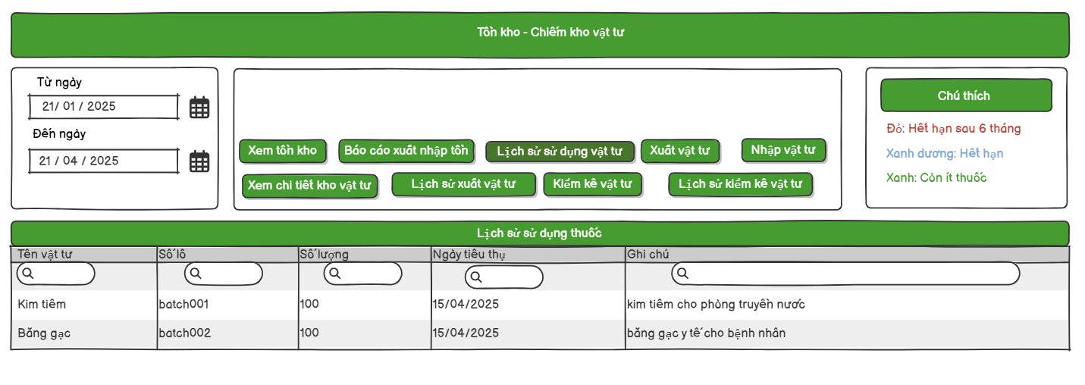

*Figure 46– View medical supplies consumption history Mock Up*

###### 3.6.3.1 UI Requirement

| **No.** | **Field Name** | **Field Type** | **Description** |
| --- | --- | --- | --- |
| 1 | Title | Text | The screen title: "Tồn kho - Chiếm kho vật tư". |
| 2 | From Date | Input Field | Date picker to select the starting date for filtering. |
| 3 | To Date | Input Field | Date picker to select the ending date for filtering. |
| 4 | View List Medical Supply Button | Button | Button to view list Medical Supply information in Inventory |
| 5 | Consume Medical Supply Report Button | Button | Display list of consume, import, expired, existing medicine in Inventory. |
| 6 | Consumption Medical Supply History Button | Button | View list of consume Medical Supply history. |
| 7 | Export Medicine Button | Button | Export medicine to use or to discard. |
| 8 | Add Medical Supply to Inventory Button | Button | Create medicine form to add medicines to inventory from suppliers . |
| 9 | Export excel | Button | Export Medical Supply list filter by date to Excel. |
| 10 | Export PDF | Button | Export Medical Supply list filter by date to PDF. |
| 11 | Annotation Field | Annotation | Displays inventory status: Red (Expired after 6 months), Green (Low stock), Blue(Expired). |
| 12 | Consume Medical Supply Detail Table | Table | Table displaying detail consume Medical Supply quantity and date used. |
| 13 | Search bar | Input Field | Input field to search for Medical Supply . |

*Table 79– View medical supplies consumption history UI Requirement*

##### 3.6.4 View detail medical supplies in inventory

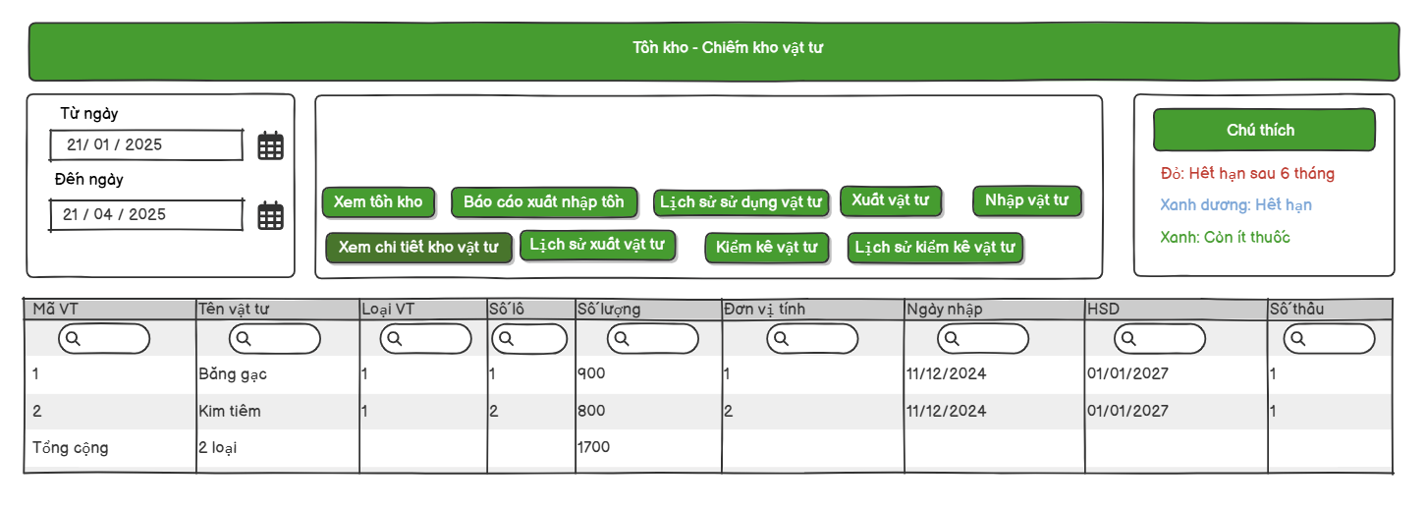

*Figure 47– View detail medical supplies in inventory Mock Up*

###### 3.6.4.1 UI Requirement

| **No.** | **Field Name** | **Field Type** | **Description** |
| --- | --- | --- | --- |
| 1 | Title | Text | The screen title: "Tồn kho - Chiếm kho vật tư". |
| 2 | From Date | Input Field | Date picker to select the starting date for filtering. |
| 3 | To Date | Input Field | Date picker to select the ending date for filtering. |
| 4 | View List Medical Supply Button | Button | Button to view list Medical Supply information in Inventory. |
| 5 | Export Report Button | Button | Button to generate inventory in/out report. |
| 6 | Usage History Button | Button | Button to view usage history of medical supplies. |
| 7 | Export Medical Supply Button | Button | Button to navigate to export medical supply screen. |
| 8 | Import Medical Supply Button | Button | Button to navigate to import medical supply screen. |
| 9 | View Supply Detail Button | Button | Button to view detailed medical supply information. |
| 10 | Export History Button | Button | Button to view history of export operations. |
| 11 | Inventory Check History Button | Button | Button to view inventory check history. |
| 12 | Medical Supply ID | Table Column | Unique identifier for the medical supply item. |
| 13 | Medical Supply Name | Table Column | Name of the medical supply item. |
| 14 | Medical Supply Category | Table Column | Category/type of the medical supply. |
| 15 | Batch Number | Table Column | Batch number of the medical supply. |
| 16 | Quantity | Table Column | Quantity available in inventory. |
| 17 | Unit of Measure | Table Column | Unit of measurement for the supply item. |
| 18 | Import Date | Table Column | The date the item was imported into inventory. |
| 19 | Expiry Date (HSD) | Table Column | Expiration date of the item (HSD). |
| 20 | Contract Number | Table Column | Contract number associated with the batch. |
| 21 | Filter Input (Search Icon) | Input Field | Input fields under each column to search/filter values. |
| 22 | Color Legend | Text | Red: Expired in 6 months; Blue: Expired; Green: Low stock. |
| 23 | Total Summary Row | Table Footer | Summary row that shows total item types and total quantity. |

*Table 80– View detail medical supplies in inventory UI Requirement*

##### 3.6.5 Conduct medical supply

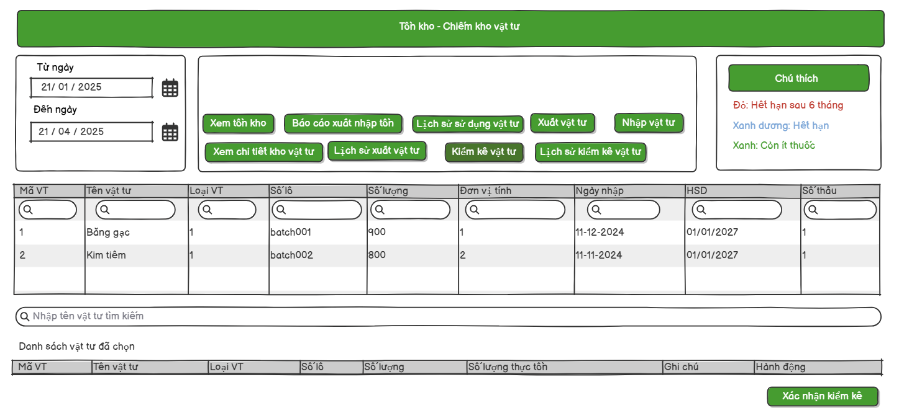

*Figure 48– Conduct medical supply Mock Up*

###### 3.6.5.1 UI Requirement

| **No.** | **Field Name** | **Field Type** | **Description** |
| --- | --- | --- | --- |
| 1 | Title | Text | The screen title: "Tồn kho - Chiếm kho vật tư". |
| 2 | From Date | Input Field | Date picker to select the starting date for filtering. |
| 3 | To Date | Input Field | Date picker to select the ending date for filtering. |
| 4 | View Inventory Button | Button | Button to view medical supply inventory. |
| 5 | Inventory Report Button | Button | Button to view inventory in/out report. |
| 6 | Usage History Button | Button | Button to view usage history of medical supplies. |
| 7 | Export Medical Supply Button | Button | Button to navigate to export medical supply screen. |
| 8 | Import Medical Supply Button | Button | Button to navigate to import medical supply screen. |
| 9 | View Detail Inventory Button | Button | Button to view detailed inventory. |
| 10 | Export History Button | Button | Button to view export history of supplies. |
| 11 | Conduct Inventory Button | Button | Button to conduct inventory checking. |
| 12 | Inventory Check History Button | Button | Button to view inventory check history. |
| 13 | Medical Supply ID | Table Column | Unique ID of medical supply item. |
| 14 | Medical Supply Name | Table Column | Name of the medical supply item. |
| 15 | Medical Supply Category | Table Column | Type/category of the medical supply. |
| 16 | Batch Number | Table Column | Batch number of the supply item. |
| 17 | Quantity | Table Column | Inventory quantity in stock. |
| 18 | Unit of Measure | Table Column | Unit of measurement for supply. |
| 19 | Import Date | Table Column | Date when the item was imported. |
| 20 | Expiry Date (HSD) | Table Column | Expiry date of the supply (HSD). |
| 21 | Contract Number | Table Column | Contract/lot number associated with the item. |
| 22 | Column Filter Inputs | Input Field | Inputs under each column to allow filtering/searching. |
| 23 | Search Medical Supply Field | Input Field | Text field to search medical supply by name. |
| 24 | Selected Medical Supply List | Table | Table showing the list of selected medical supplies for conducting inventory. |
| 25 | Real Quantity | Table Column | Input field in the selected list to enter the actual counted quantity. |
| 26 | Note | Table Column | Input field to add any notes during inventory check. |
| 27 | Action | Table Column | Action column to perform functions like remove/edit an item. |
| 28 | Confirm Inventory Button | Button | Button to confirm the inventory check. |
| 29 | Color Legend | Text | Color hints: Red (expire in 6 months), Blue (expired), Green (low stock). |

*Table 81– Conduct medical supply UI Requirement*

##### 3.6.6 View history medical supply conducted

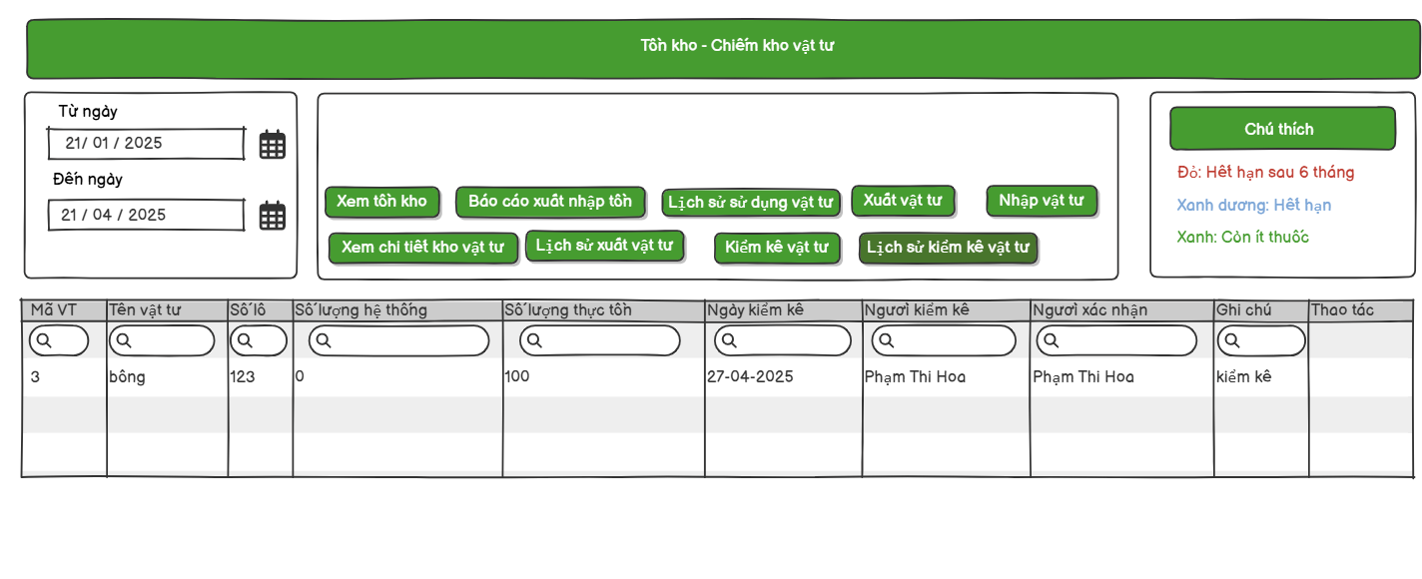

*Figure 49– View history medical supply conducted Mock Up*

###### 3.6.6.1 UI Requirement

| **No.** | **Field Name** | **Field Type** | **Description** |
| --- | --- | --- | --- |
| 1 | Title | Text | The screen title: "Tồn kho - Chiếm kho vật tư". |
| 2 | From Date | Input Field | Date picker to select the starting date for filtering. |
| 3 | To Date | Input Field | Date picker to select the ending date for filtering. |
| 4 | View Inventory Button | Button | Button to view medical supply inventory. |
| 5 | Inventory Report Button | Button | Button to view inventory in/out report. |
| 6 | Usage History Button | Button | Button to view usage history of medical supplies. |
| 7 | Export Medical Supply Button | Button | Button to navigate to export medical supply screen. |
| 8 | Import Medical Supply Button | Button | Button to navigate to import medical supply screen. |
| 9 | View Detail Inventory Button | Button | Button to view detailed inventory. |
| 10 | Export History Button | Button | Button to view export history of supplies. |
| 11 | Conduct Inventory Button | Button | Button to conduct inventory checking. |
| 12 | Inventory Check History Button | Button | Button to view inventory check history. (this screen) |
| 13 | Medical Supply ID | Table Column | Unique ID of the medical supply item. |
| 14 | Medical Supply Name | Table Column | Name of the medical supply item. |
| 15 | Batch Number | Table Column | Batch number of the medical supply. |
| 16 | System Quantity | Table Column | Quantity recorded in the system. |
| 17 | Actual Quantity | Table Column | Quantity actually counted during inventory check. |
| 18 | Check Date | Table Column | Date when the inventory check was conducted. |
| 19 | Checked By | Table Column | Person who conducted the inventory check. |
| 20 | Confirmed By | Table Column | Person who confirmed the inventory check. |
| 21 | Notes | Table Column | Any remarks related to the inventory checking. |
| 22 | Action | Table Column | Action buttons (e.g., view details, edit). |
| 23 | Column Filter Inputs | Input Field | Inputs under each column for filtering/searching data. |
| 24 | Color Legend | Text | Color hints: Red (expire in 6 months), Blue (expired), Green (low stock). |

*Table 82– View history medical supply conducted UI Requirement*

##### 3.6.7 Dispense medical supplies

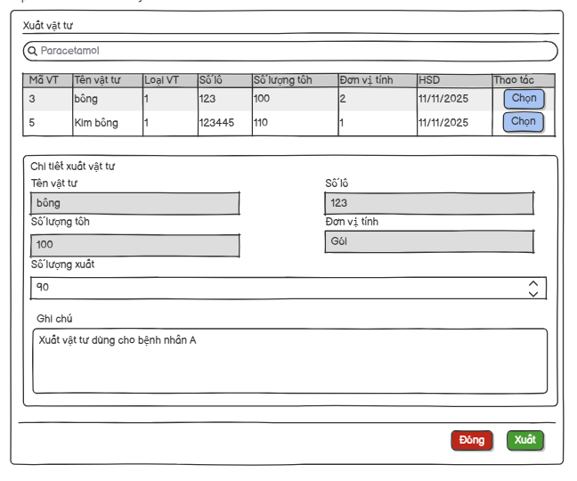

*Figure 50– Dispense medical supplies Mock Up*

###### 3.6.7.1 UI Requirement

| **No.** | **Field Name** | **Field Type** | **Description** |
| --- | --- | --- | --- |
| 1 | Title | Text | The screen title: "Xuất vật tư". |
| 2 | Search Medical Supply | Input Field | Text box to search medical supplies by name (e.g., Paracetamol). |
| 3 | Medical Supply Table | Table | Shows list of available supplies with detailed information. |
| 4 | Medical Supply ID | Table Column | Unique ID of the medical supply item. |
| 5 | Medical Supply Name | Table Column | Name of the medical supply item. |
| 6 | Type | Table Column | Type/category ID of the medical supply. |
| 7 | Batch Number | Table Column | Batch number of the medical supply. |
| 8 | Available Quantity | Table Column | Current stock quantity available. |
| 9 | Unit | Table Column | Unit of measurement (e.g., box, piece). |
| 10 | Expiration Date (HSD) | Table Column | Expiration date of the batch. |
| 11 | Action Button | Button | "Chọn" button to select a supply item for dispensing. |
| 12 | Detail Section Title | Text | "Chi tiết xuất vật tư" - Detailed information of the selected item. |
| 13 | Selected Supply Name | Text Field | Auto-filled name of the selected supply. |
| 14 | Selected Batch Number | Text Field | Auto-filled batch number of the selected supply. |
| 15 | Available Quantity Field | Text Field | Auto-filled stock quantity of the selected batch. |
| 16 | Unit Field | Text Field | Auto-filled unit of measurement. |
| 17 | Dispensed Quantity | Input Field | Input field to enter the quantity to be dispensed. |
| 18 | Note | Text Area | Optional remarks field (e.g., reason for dispensing: "cho bệnh nhân A"). |
| 19 | Close Button | Button | "Đóng" button to cancel or close the modal. |
| 20 | Confirm Dispense Button | Button | "Xuất" button to confirm and dispense the selected supply. |

*Table 83– Dispense medical supplies UI Requirement*

##### 3.6.8 Add medical supplies to inventory

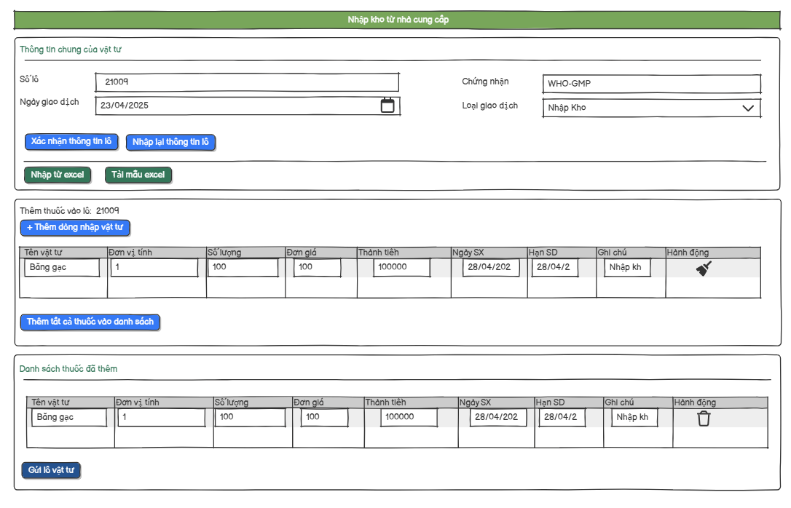

*Figure 51– Add medical supplies to inventory Mock Up*

###### 3.6.8.1 UI Requirement

| **No.** | **Field Name** | **Field Type** | **Description** |
| --- | --- | --- | --- |
| 1 | Title Screen | Title Field | The screen title: "Nhập kho từ nhà cung cấp". |
| 2 | Title Form | Title Field | The screen title: "Thông tin chung của vật tư". |
| 3 | Batch form to import | Form | Display form of batch medical supply to import. |
| 4 | Batch Number | Label | Label for batch number input. |
| 5 | Batch number input field | Input field | Input Batch number |
| 6 | Certificate number | Label | Label for certificate number input. |
| 7 | Certificate number input field | Input field | Input Batch number |
| 8 | Transaction Date | Label | Label for transaction date input. |
| 9 | Transaction Date Input field | Date | Input Batch number |
| 10 | Transaction Type | Label | Label for transaction type dropdown. |
| 11 | Transaction Type input field | Drop Down | Input Batch number |
| 12 | Supplier | Label | Label for supplier input. |
| 13 | Supplier search bar | Input field | Input Batch number |
| 14 | Confirm batch button | Button | Confirm the batch info and proceed to add medical supply. |
| 15 | Re-input batch button | Button | Clear or re-enter batch information. |
| 16 | Import medicine from excel button | Button | Upload medical supply batch list from Excel file. |
| 17 | Download excel form button | Button | Download template Excel file for medical supply import. |
| 18 | Export imported medical supply history to excel button | Button | Export medical supply import history to Excel file. |
| 19 | Export imported medical supply history to PDF button | Button | Export medicine import history to PDF file. |
| 20 | Add medical supply to batch form | Form | Form to add medical supply details to the current batch. |
| 21 | Add row button | Button | Add a new row for medicine entry. |
| 22 | Medical supply information table | Table | Display list of medical supply added in current session. |
| 23 | Add medical supply to list button | Button | Add current medical supply input to the list. |
| 24 | Clear row button | Button | Clear input in the current row. |
| 25 | List medicine has added form | Form | Form displaying list of added medical supply. |
| 26 | Send batch button | Button | Submit the full batch for processing/import. |

*Table 84– Add medical supplies to inventory UI Requirement*

## 4. Non-Functional Requirements

4.1 Performance Requirements

- Key operations such as logging in, retrieving medical records, and looking up medications must have a response time of less than 3 seconds.

4.2 Security Requirements

- There must be a secure user authentication mechanism including password encryption.

4.3 Usability Requirements

- The user interface must be easy to use, with clear instructions, suitable for medical staff with basic information technology skills.

- Common functions such as prescribing, issuing supplies, and viewing statistics must be accessible after only 5 clicks at most.

4.4 Compatibility

- The backend system must support connection to standard SQL databases such as SQL Server.

## 5. Requirement Appendix

### 5.1 Business Rules

| **ID** | **Rule Definition** |
| --- | --- |
| BR-01 | Users can only log in if their account is active and the login credentials are correct. |
| BR-02 | Only active users (status = "True") can log in |
| BR-03 | Users must provide their registered email |
| BR-04 | Reset link is valid for 1 hour. |
| BR-05 | New passwords must meet complexity requirements |
| BR-06 | Email address must follow a valid email format (e.g., name@example.com) and must not be left empty |
| BR-07 | Phone number must contain only digits and follow the standard length (e.g., 10 digits) |
| BR-08 | Email and phone number must not be duplicated |
| BR-09 | Date of birth field user must be above 18 |
| BR-10 | Only users with the role Admin can access and manage the user list. |
| BR-11 | Admin can only deactivate users, not delete them permanently. |
| BR-12 | Deactivating a user should update the user's status and prevent login |
| BR-13 | The admin must confirm the action before the user status is updated. |
| BR-14 | When adding a new user, all required fields must be validated (e.g., username, email, password) |
| BR-15 | Duplicate usernames or emails are not allowed when creating new users |
| BR-16 | The user must provide the correct current password to change to a new password. |
| BR-17 | The new password must meet the defined security policy (e.g., minimum 8 characters, must include uppercase, lowercase, number, and special character). |
| BR-18 | The new password and confirm password fields must match. |
| BR-19 | Only users with the Pharmacist and Admin role are allowed to access the medicine list. |
| BR-20 | The system only allows adding medicine if all required information has been provided. |
| BR-21 | Medicine batch numbers must not be duplicated |
| BR-22 | Invalid medicine field |
| BR-23 | Only permitted cases (quantity, expiry date, notes) are updated. |
| BR-24 | Medicine import history displays information: medicine name, batch number, quantity, import date, supplier, notes, etc,... |
| BR-25 | Pharmacists can filter by date |
| BR-26 | Medicine history can be exported to CSV, Excel or PDF file. |
| BR-27 | Medicine searches support the following criteria: name, drug type, manufacturer, expiration date, etc,... |
| BR-26 | Materials are not allowed to have duplicate batch numbers and certification numbers. |
| BR-27 | The material must have an expiration date greater than the current date. |
| BR-28 | Production date must be less than current date |
| BR-29 | Quantity is a positive real number |
| BR-30 | Medical Supplies must exist. |
| BR-31 | The quantity used must be less than or equal to the quantity in stock. |
| BR-32 | Consumption can be update can be updated on the date created |
| BR-33 | Only users with the Doctor and Admin role are authorized to access. |
| BR-34 | All required fields must be validated before saving |
| BR-35 | Editing is only allowed within 24 hours of the record creation |

*Table 85– Business Rule*

### 5.2 System Messages

| **#** | **Message code** | **Message Type** | **Context** | **Content** |
| --- | --- | --- | --- | --- |
| 1 | MSG01 | Toast message | Leave UserName or Password field blank | *Show error toast “Vui lòng nhập đầy đủ tên đăng nhập và mật khẩu.”* |
| 2 | MSG02 | Toast message | Account Locked | *Show error toast “Tài khoản không tồn tại hoặc đã bị vô hiệu hóa.”* |
| 3 | MSG03 | Toast message | Invalid credentials | *Show error toast “Sai tài khoản hoặc mật khẩu.”* |
| 4 | MSG04 | Toast message | Email not registered in the system | *Show error toast “Không tìm thấy Email.”* |
| 5 | MSG05 | Toast message | Successful send mail to reset password | *Show error toast “Đã gửi Email thành công.”* |
| 6 | MSG06 | Toast message | Leave Email field blank | *Show error toast “Leave UserName or Password field blank”* |
| 7 | MSG07 | Toast message | Invalid email format | *Show error toast “Định dạng email không hợp lệ”* |
| 8 | MSG08 | Toast message | Successful change password | *Show error toast “Đặt lại mật khẩu thành công”* |
| 9 | MSG09 | Toast message | Invalid credentials new password | *Show error toast “Mật khẩu phải dài từ 8 đến 32 ký tự, chứa ít nhất một số, chữ in hoa và kí tự đặc biệt”* |
| 10 | MSG10 | Inline message | Leave new password field blank | *Show inline warning”Please fill out this field”* |
| 11 | MSG11 | Popup message | After press save button | *Show popup message”Bạn có chắc chắn muốn lưu thay đổi hồ sơ?”* |
| 12 | MSG12 | Toast message | Input Invalid Email | *Show error toast “The Email field is not a valid e-mail address.”* |
| 13 | MSG13 | Toast message | Input Invalid Date of birth | *Show error toast “Người dùng phải trên 18”* |
| 14 | MSG14 | Toast message | Successful update information | *Show toast “Cập nhật thành công”* |
| 15 | MSG15 | Toast message | Leave input field blank | *Show error toast “Hãy nhập Email”* |
| 16 | MSG16 | Toast message | After confirmed change user’s status | *Show toast “Đã đổi trạng thái”* |
| 17 | MSG17 | Popup message | Show pop up to confirm save or not | *Show popup “Bạn có chắc chắn muốn thay đổi trạng thái người dùng không?”* |
| 18 | MSG18 | Toast message | Already exist account in system | *Show error toast “Tài khoản đã tồn tại”* |
| 19 | MSG19 | Toast message | Input duplicated email | *Show error toast “Email đã tồn tại”* |
| 20 | MSG20 | Toast message | Input duplicated phone number | *Show error toast “Số điện thoại đã tồn tại”* |
| 21 | MSG21 | Toast message | Successful create account | *Show toast “Tạo tài khoản thành công”* |
| 22 | MSG22 | Toast message | Leave current password, new password field blank | *Show error toast “Vui lòng nhập đầy đủ thông tin”* |
| 23 | MSG23 | Toast message | Input wrong current password | *Show error toast “Sai mật khẩu cũ”* |
| 24 | MSG24 | Toast message | Successful change password | *Show toast “Đổi mật khẩu thành công. Vui lòng đăng nhập lại”* |
| 25 | MSG25 | Toast message | Input invalid batch number | *Show error toast “Số lô chỉ được chứa chữ cái, số và dấu gạch ngang”* |
| 26 | MSG26 | Toast message | Input invalid Certificate number | *Show error toast “Số chứng nhận chỉ được chứa chữ cái, số và dấu gạch ngang”* |
| 27 | MSG27 | Inline message | Input invalid batch number | *Show error “Số lô chỉ được chứa chữ cái, số và dấu gạch ngang.”* |
| 28 | MSG28 | Inline message | Input invalid Certificate number | *Show error “Số chứng nhận chỉ được chứa chữ cái, số và dấu gạch ngang.”* |
| 29 | MSG29 | Toast message | Input invalid Transaction date | *Show error toast “Ngày sản xuất phải nhỏ hơn hoặc bằng ngày hiện tại.”* |
| 30 | MSG30 | Toast message | Input invalid Quantity | *Show error toast “Giá trị không được nhỏ hơn 1”* |
| 31 | MSG31 | Toast message | Successful add medicine to inventory | *Show toast “Thêm lô thuốc thành công!”* |
| 32 | MSG32 | Toast message | Successful updated medicine information | *Show error toast “Thông tin thuốc đã được cập nhật thành công.”* |
| 33 | MSG33 | Inline message | No medicine match input search | *Show inline error “Không tìm thấy thuốc”* |
| 34 | MSG34 | Inline message | No match input search | *Show inline error “Không tìm thấy dữ liệu”* |
| 35 | MSG35 | Toast message | Added successfully | *Show toast”Đã thêm vật tư thành công”* |
| 36 | MSG36 | Toast message | An error occurred while adding medical supply. | *Show toast ”Có lỗi xảy ra trong quá trình thêm vật tư”* |
| 37 | MSG37 | Toast message | Consump successfully | *Show toast ”Xuất vật tư thành công”* |
| 38 | MSG38 | Toast message | An error occurred while adding a medical record. | *Show toast ”Vui lòng sửa các lỗi sau”* |
| 39 | MSG39 | Toast message | Successful added a new medical record | *Show toast”Thêm bệnh nhân thành công!”* |
| 40 | MSG40 | Toast message | Successful added new use medical supply form | *Show toast ”Tạo đơn vật tư thành công!”* |
| 41 | MSG41 | Toast message | No medical supply added to use medical supply form | *Show toast”Vui lòng thêm ít nhất một loại vật tư! ”* |
| 42 | MSG42 | Toast message | An error occurred while adding use medical supply. | *Show toast”Lỗi khi tạo đơn vật tư”* |
| 43 | MSG43 | Toast message | Update successful | *Show toast”Cập nhật thành công”* |
| 44 | MSG44 | Toast message | No medicine added to medicine form | *Show toast”Vui lòng thêm ít nhất một loại thuốc ”* |
| 45 | MSG45 | Toast message | An error occurred while adding new medicine to external medicine prescription. | *Show toast”Lỗi khi tạo đơn thuốc ngoài”* |
| 46 | MSG46 | Toast message | An error occurred while adding medicine to medicine prescription. | *Show toast”Vui lòng chọn một thuốc từ danh sách tìm kiếm!”* |
| 47 | MSG47 | Toast message | Successful adding medicine to medicine prescription. | *Show toast”Tạo đơn thuốc thành công!”* |
| 48 | MSG48 | Toast message | Successful adding medicine to medicine prescription. | *Show toast”Tạo đơn thuốc kê ngoài thành công!”* |

*Table 86– System Message Table*